**WOMEN ENABLED INTERNATIONAL**

**FISCAL YEAR 2023 ANNUAL REPORT**

Leadership message

Dear friend,

2023 was a transformational year for Women Enabled International. This report highlights pivotal moments in our work and provides a preview of what's next for us as the only global organization dedicated to advancing rights at the intersection of gender and disability.

In her first full year as Executive Director, Maryangel brought to bear her lived experience, business acumen, and movement roots as founder of a national disabled feminist rights group in Mexico, to lead WEI through a dynamic and participatory strategic planning process that has put us on a path to continued success and sustainability.

WEI’s new 5-year Strategic Plan, which will guide our work 2024-2028, articulates our unique role as a connector of intersecting global movements, a thought leader on key issues, an influencer of narratives and decision-makers, and an amplifier of advocacy efforts driven by disabled feminist leaders in every country and community.

While planning and structuring for a sustainable future, the WEI team had incredible impact in real time. We deepened partnerships, bolstered movements, increased representation in key advocacy spaces, and created innovative, research-based approaches to improving access to essential rights-based programs and services. We also strengthened WEI from the inside, expanding policies and practices that promote solidarity, joy, care, and rest.

As a valued member of the WEI community —along with our committed staff, board, partners, and funders— you contributed to this powerful progress. We hope you share our pride in these accomplishments and join us in solidarity with disabled feminists and allies worldwide until equality and justice are enjoyed by all.

We recognize the pressing challenges gender and disability rights are facing today, and now more than ever, we are convinced that the future of disability rights is feminist, and the future of gender equality is inclusive.

With gratitude,

Maryangel and Catherine

QUOTE:

“Maryangel’s commitment to feminist leadership and her ability to lead strategically, with dynamism and intentionality, has elevated WEI’s work and the work of disability justice movements and activists globally. Together with her team, she has been able to build in-roads with different stakeholders and movements all while strengthening the culture and programs of WEI as an organization. The future is bright and just with Maryangel at the helm.”

-Juliana Vélez

Global Program Officer

Foundation for a Just Society

# Women Enabled International Our mission

As feminists with disabilities and allies, Women Enabled International advances human rights and justice at the intersection of gender and disability to challenge exclusionary, unjust systems, and support the leadership and center the voices of women, girls, and gender-diverse people with disabilities globally.

# 2023 Highlights

* Participated at **19 global advocacy forums** focused on gender and/or disability where we **reached out to 6,5000 activists**.
* The Feminist Accessibility protocol **obtained 222 signatories** from **33 different countries**.
* With our work in the Pacific region, we reached **150 women and young people** with disabilities.
* We welcomed **5,200 new followers** from around the globe, including Latin America, Africa, Europe, and North America. That represents a **28% growth in audience** across our channels.
* Our audience **engaged** with our content over **20,000 times**—likes, shares, saves, and reposts.
* We published **13 stories from 7 different countries** that spoke about the different life experiences of being a woman or a gender-diverse person with a disability.
* **100,970 people visited our website** to learn more about our work and make use of our resources, trainings, reports, and methodologies.
* We designed a **one-of-a-kind OPD* Curriculum** with partner organizations in Botswana and China. This curriculum will help organizations and activists worldwide to become champions and advocates of their own sexual and reproductive health and rights.
* We collaborated with **223 partners across the globe**, including federal and local governments, UN agencies and organizations, health services providers, as well as grassroots organizations and activists.
* Our work building trustworthy relationships and our persistent advocacy landed **5 key conversations** with members of the UN CEDAW**\*\*** committee to promote equal access to decision-making spaces to women and girls with disabilities in global strategies and spaces  .  
    
  **Feminist disabled leadership is at the core of our work. This year we worked tirelessly to deepen connections across movements to ensure the voices of women and girls with disabilities around the world are heard, and the impact of their advocacy work is felt around the world.**

*\*Organizations of people with disabilities*

***\*\*****Convention on the Elimination of All Forms of Discrimination against Women*

# Our impact

## Shaping global conversations to change hearts and minds

Women Enabled International has strategically positioned itself at the forefront of global discussions on gender and disability rights. WEI organized and participated in 19 events at key international forums on gender and disability rights, this work allows us to:

* **Amplify Intersectional Advocacy**: This year, WEI supported 11 global partners to advocate for their rights at the United Nations, including disabled feminist leaders from Malawi, Ghana, the Philippines, Poland, Kenya, and the U.S.
* **Expand Global Reach**: At major gender and disability forums, **WEI reached over 6,500 activists**, fostering a robust global network of advocates committed to advancing the rights of women and girls with disabilities through inclusive feminist movements.
* **Influence Policy and Practice**: WEI’s joint advocacy with local disabled feminist leaders resulted in the UN Committee on the Rights of Persons with Disabilities issuing 19 recommendations to advance rights at the intersection of gender and disability in Malawi.

This strategic engagement underscores WEI’s commitment to advocating for the rights and empowerment of women, girls, and gender-diverse people with disabilities on a global scale.

**Events**

* March 2023 we were in the Commission on the Status of Women
* June 2023 we were in the Conference of States Parties to the Convention on the Rights of Persons with Disabilities
* July 2023 we were in the Women Deliver conference
  + WEI led a roundtable discussion exploring gender, disability, age, and care. That conversation led to the creation of policy priorities intended to strengthen care policies and intersectional movements for care justice.
* In September 2023 we were in Free Future 2023: Preventing Gender Violence Around the World
  + WEI’s Executive Director, Maryangel García-Ramos was part of the event hosted by the Ford Foundation. This gathering unites activists, leaders, and change makers committed to ending gender-based violence globally including: #MeToo’s Tarana J. Burke, activist Kasha Jacqueline Nabagesera, Rise founder Amanda Nguyen, and iconic legal scholar Anita Hill.

**We deserve equal access to decision-making spaces!\***\**Gertrude Oforiwa Fefoame during CEDAW*

Accessibility is a first –and non-negotiable– step. This is the message that WEI brought to **Committee on the Elimination of Discrimination against Women** (CEDAW) in Geneva on behalf of the Inclusive Generation Equality Collective.

QUOTE:  
**“We are still fighting to enter decision-making spaces on an equal basis with others, a fight that pulls our attention away from the substantive contributions we can and should make to those spaces.”**

***–*** *Gertrude Oforiwa Fefoame, Global Advocacy Adviser, Sightsavers and member of the Inclusive Gender Equality Collective*

As part of her Statement on Equal and Inclusive Participation of Women in Decision-making Systems

## Training activists, supporting regional networks, and championing global movements

WEI champions global movements by working in partnership to:

* Train activists to be better equipped to advocate for their rights, particularly in the areas of sexual and reproductive health and rights, and gender-based violence
* Ensure that women, girls, and gender-diverse people with disabilities are meaningfully included in gender equality conversations and decision-making spaces
* Ensure women, girls, and gender-diverse people with disabilities have access to sexual and reproductive health services
* Support activists from across the globe as they engage in collective action for their rights

During 2023…

* We expanded activist networks across Inclusive Generation Equality Collective (IGEC), US Gender and Disability Justice Alliance, and Latin American and Caribbean Collective (LAC Collective) by **81 members**, which represents over **55% increase in overall membership**.
* We reached **222 signatories** since the launch of Feminist Accessibility Protocol, with **121 of those signing in 2023,** including **States, UN agencies, feminist civil society, and other feminist actors**.

**33 countries are represented** by those signatories including: Argentina, Brazil, Cameroon, Canada, Chad, Chile, China, Colombia, the Democratic Republic of Congo, Ecuador, Eswatini, Ghana, India, Italy, Kenya, Liberia, Mexico, Nepal, Nigeria, Peru, Poland, Portugal, Rwanda, Serbia, Sierra Leone, Somalia, South Sudan, Spain, Uganda, the United States of America, Yemen, Zambia, and Zimbabwe.

This protocol is a groundbreaking set of commitments that seek to ensure feminists with disabilities are meaningfully included in gender equality spaces and has been used to advocate for access, inclusion, and leadership at key gender equality spaces in 2023.

**Work in the Pacific**

The Community-Based Sexual and Reproductive Health Officers Programme was a joint effort by WEI, the Fijian Ministry of Health, [UNFPA Pacific](https://www.linkedin.com/company/unfpa-pacific/), [Pacific Disability Forum](https://www.linkedin.com/company/pdfsec/), Fiji Disabled People’s Federation, and [Medical Services Pacific](https://www.linkedin.com/company/medical-services-pacific/).   
  
Our collective work is a key component of the Transformative Agenda for Women, Adolescents, and Youth in the Pacific funded by the [Australian Department of Foreign Affairs and Trade](https://www.linkedin.com/company/department-of-foreign-affairs-and-trade/). Outreach in the Pacific region included **2 trainings and 6 outreach visits** that reached **approximately** **150 women and young people with disabilities**.    
  
A woman with a disability in Fiji who participated in one of our trainings said: **“It’s very important for us to know about [reproductive health] and what reproductive health means for us. At times we are not included in a lot of spaces or workshops that share this kind of topic.”**

QUOTE:

“Women Enabled International is a global leader on addressing violence against women and girls with disabilities. They are a long-standing and trusted partner of the United Nations Population Fund (UNFPA) towards the inclusion of women and young people with disabilities in efforts to ensure sexual and reproductive health and rights, and freedom from gender-based violence.”

-Leyla Sherafi

Chief, Gender and Human Rights Branch

**OPD* Curriculum***\*Organizations of Persons with Disabilities*

WEI partnered with **organizations in Botswana and China** to develop the OPD curriculum, a program designed to serve as a resource for people with disabilities to understand and become champions of accessible and inclusive sexual and reproductive health and rights and gender‑based violence services.

Financials 2023

WEI continued its growth trajectory in 2023, increasing our operating budget by 48% from the previous year. We expanded our core programming while also strengthening our infrastructure and financial resilience to ensure the sustainability of our work and our global movements. These pie charts illustrate our strong fundraising results and responsible stewardship of organizational resources.

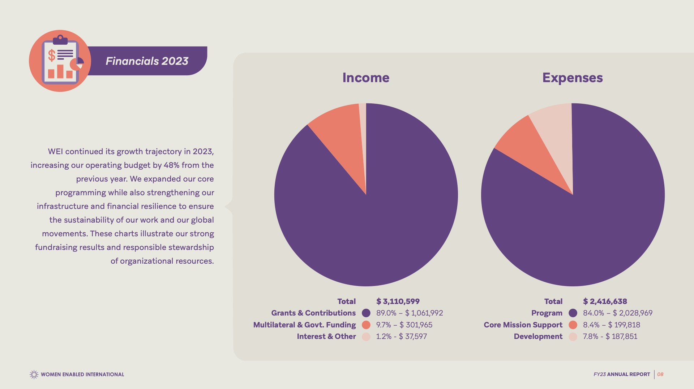

Above there is a graphic with two pie charts:

On the left, the income pie chart uses the color purple to show Grants and Contributions, representing 89% of the pie chart or $1,061,992. Then in coral, is Multilateral and government funding, representing 9.7% of the pie chart, or $301,965

and in a faded coral is Interest and other, representing 1.2% of the pie chart, or $37,597

The total is $3,110,599

On the right there is the expenses pie chart. It uses purple to represent Program expenses, and these expenses represent 84% of the pie chart or $2,028,969. In coral there is Core mission support, representing 8.4%, or $199,818, and Development in a faded coral, representing 7.8% of the pie chart or $187,851. The Total is $2,416,638

Our donors

**Thank you to our supporters!**

WEI is deeply grateful to our growing community of funding partners, whose generosity is critical as we face increasing global threats to the safety and essential rights of women, girls, and gender-diverse people with disabilities.

Channel Foundation, Disability Inclusion Fund, Disability Rights Fund, Equal Justice Works, Ford Foundation, Foundation for a Just Society, Gucci, The New York Women’s Foundation, Open Society Foundations, PRBB Foundation, United Nations Population Fund, Urgent Action Fund, Wellspring Philanthropic Fund, and individual donors.

**Make a lasting impact**!

Your support transforms lives –empowering women, girls, and gender-diverse people with disabilities. Be a driving force for change! Donate at [womenenabled.org/donate](https://womenenabled.org/donate/)