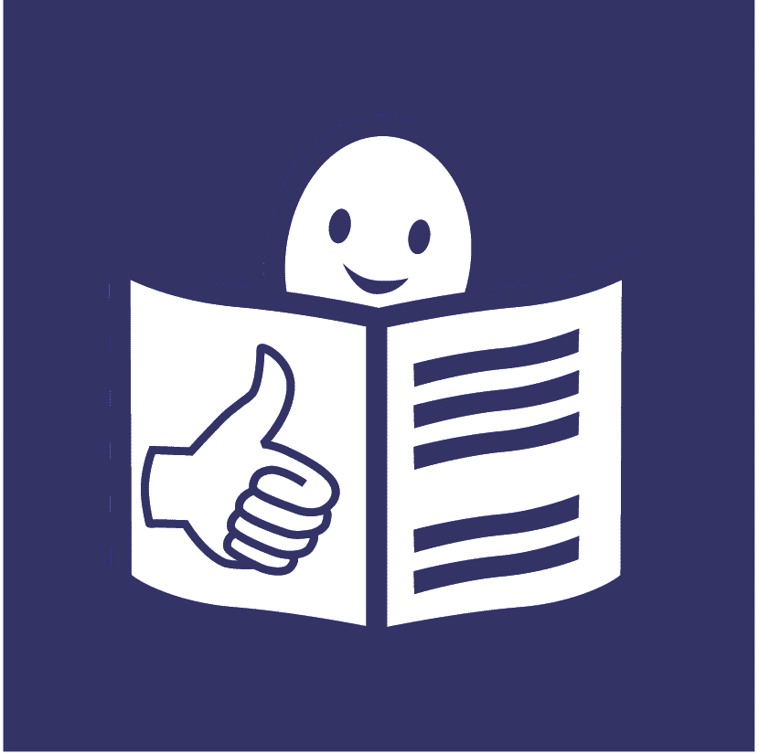

Easy to read
Making sure that women and girls with disabilities can take part in important work to make the world better for women and girls

This document has a list of work that governments and organizations can promise to do to make that happen.

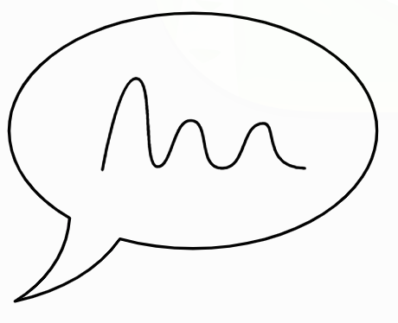
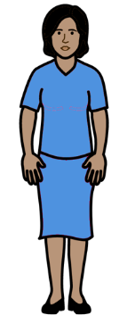
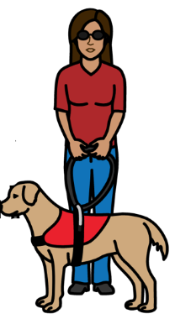
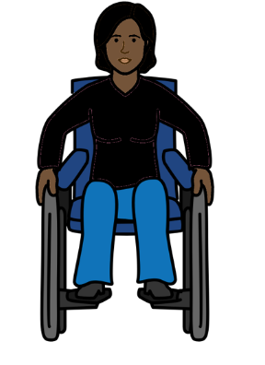

Feminist Accessibility Protocol

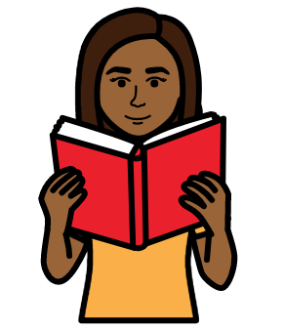
What is in this document

About this document Page 3

How this document was made Page 5

The list of work for governments and Page 6
organizations to do

About this document

This document is about making sure that important work to make life better for women and girls is easy for women and girls with disabilities to take part in.

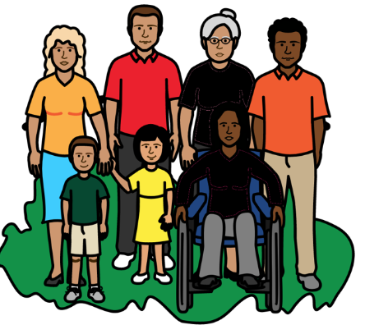

That means important work to make sure that women and girls everywhere are treated fairly and get their human rights.

Everyone has human rights. Like the right to be safe and treated fairly.

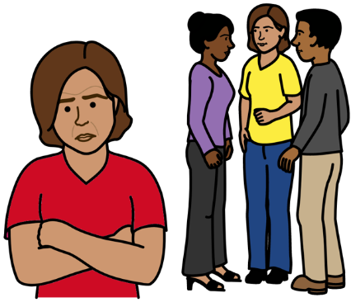

At the moment women and girls with disabilities are often left out of that work.

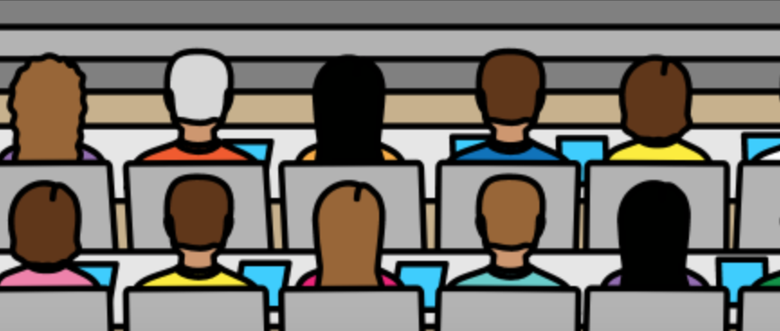
For example, there was a big meeting in 2021 about making the world better and fairer for women and girls.

It was called the Generation Equality Forum.
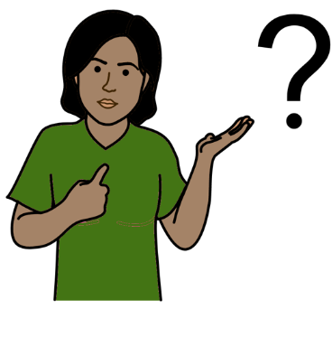
But many women and girls with disabilities
could not take part in the meeting or help to make decisions.

The organizations running the meeting did not make it easy for them to take part.

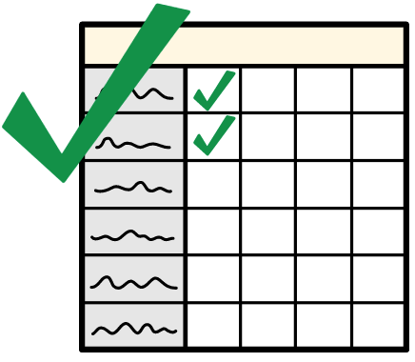

This document was made to help change that for future meetings and events.

It has a list of work for governments and organizations to do to make sure that women and girls with disabilities can take part in future meetings.

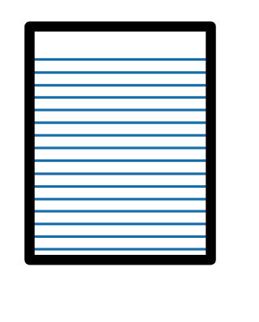

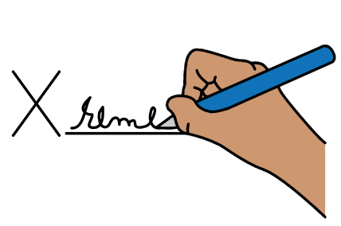
This document will also help governments and organizations to carry out important promises that governments have made about the rights of women and girls.

That includes the rights of women and girls with disabilities.
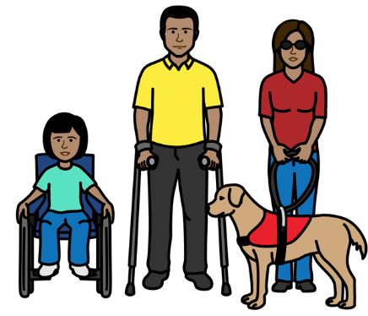

This document is about women and girls with disabilities.
It is also about people with disabilities who are not the gender that people say they are.
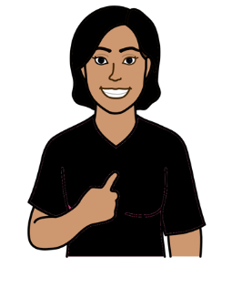
Gender is about being a woman, a girl, a man, a boy or someone else.

For example, someone might be told that they are a boy.

But they are not a boy.

They are a girl or another gender.

How this document was made
The list of work in this document was made by a group of women with disabilities across the world and other people who support their rights.

The group is called the Inclusive Generation Equality Collective.
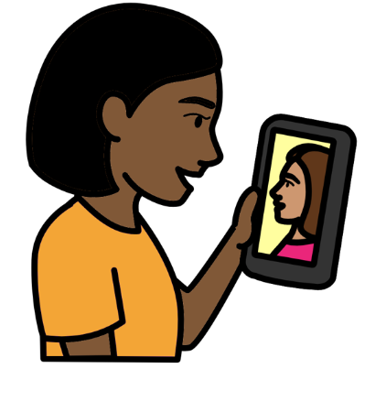
Or IGEC for short.

The group asked women with different disabilities around the world what they thought should be in this document first.

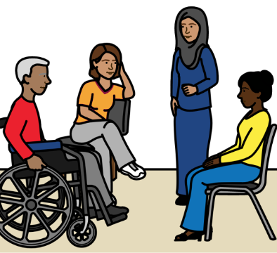
The list of work for governments and organizations to do

That means all organizations that have meetings and events about making the world fairer for women and girls.
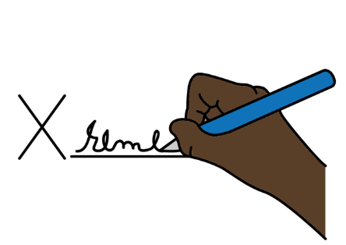

Governments and organizations can sign this document to show that they promise to do the things it says.

What we will do to make sure that women and girls with disabilities can take part in our meetings and help to make decisions.

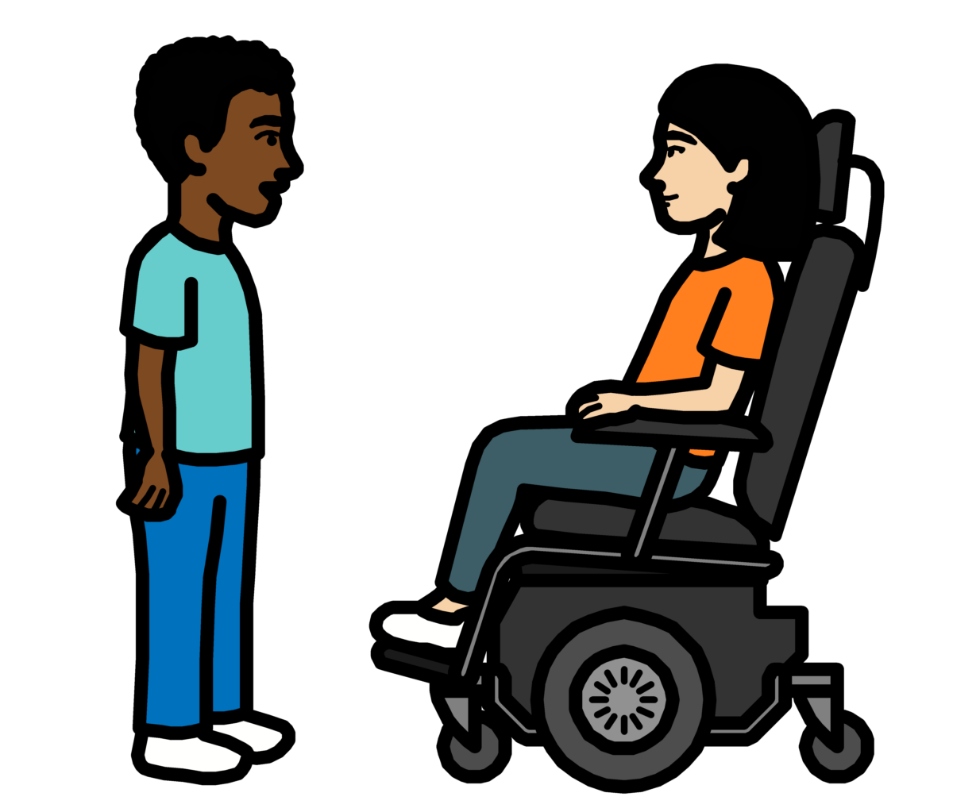
Meetings also mean events.
1

We agree that it is important for women and girls with disabilities to take part in all meetings to do with making the world fairer for women and girls.

Women and girls with disabilities should also help to plan the meetings.

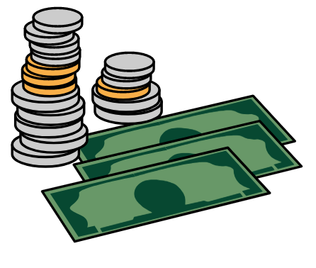
We will spend money to make sure that women and girls with disabilities can take part in our meetings or speak at them.
2

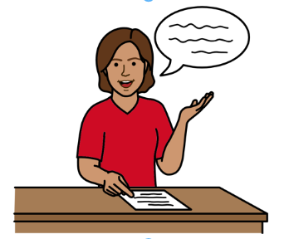

3
We will tell everyone helping to run the meetings what they can do to make sure that women and girls with disabilities can take part and make decisions.

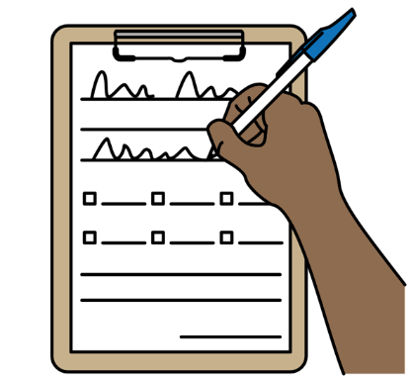

4
We will make it easy for women and girls with disabilities to sign up to our meetings and say they want to take part.

We will ask women and girls with disabilities if they need any support when they first say that they want to take part.
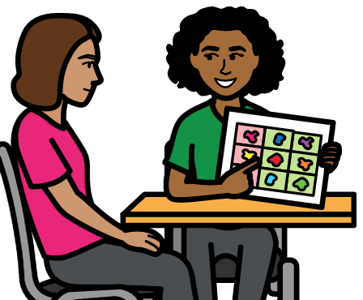

That could be any kind of support.
Like support to get to the meeting.
Or support to do with information and communication.

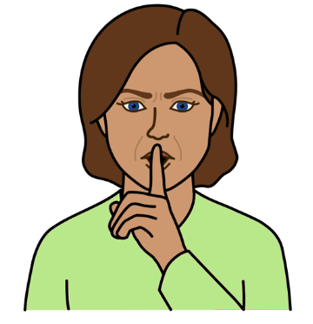
We will keep the information that women and girls with disabilities give us private and safe.

That means information about the support they need and their disability.

5
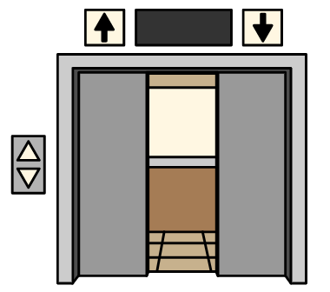
We will make sure that the meeting place is easy for women and girls with disabilities to get into and move around in.

That means having things like:
- Elevators.
- Ramps.
- Toilets that are easy for people with disabilities to use.
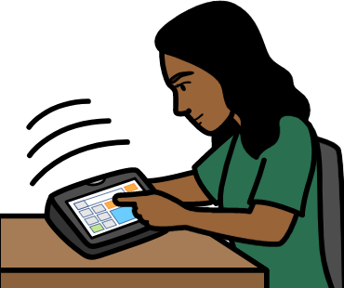
- Enough space for support people.

6
We will work to make sure that all women and girls with disabilities can take part in our meetings.

That means they can be leaders and help to make decisions too.

That includes women and girls with disabilities who have often been left out.

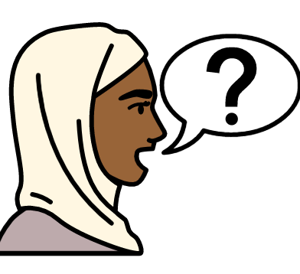
We will work to make it easy for women and girls with disabilities to communicate in the meetings.
7

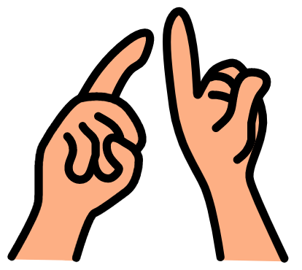
For example, in big meetings for
everyone we will have:
- Sign language.

- The words that people say written on a screen for people who find it hard to hear.

- Information in other languages if people need it.
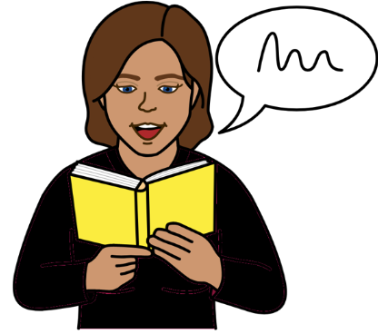

8

We will make information easy for women and girls with disabilities to understand before, during and after our meetings.
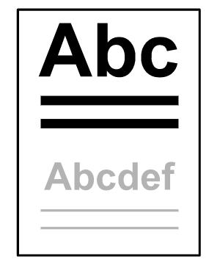
For example, some people might want information in:
- Easy words with pictures. This is called easy read.
- Large writing.
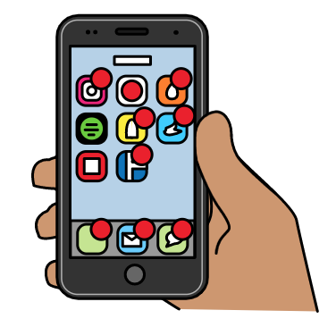
- Braille.

That includes easy to understand information on websites and social media like Twitter and Facebook.

This information will be checked by women and girls with different disabilities first.
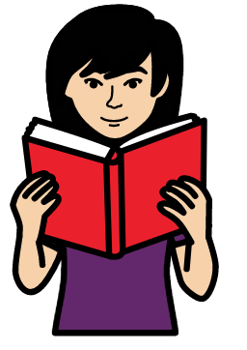
We will also tell people before the meeting how we are making it easy for women and girls with disabilities to take part.

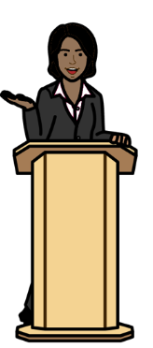

9

We will work to make our meetings easy for women and girls with mental health conditions and women and girls with autism to take part in.

For example, we will give women and girls with disabilities:
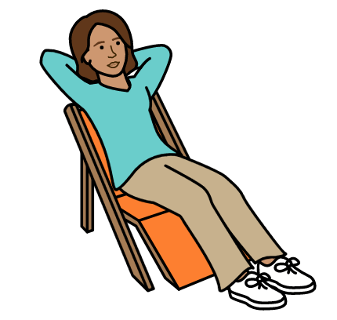
- Clear notes about what will happen at the meeting.

- Breaks during the meeting.

- A quiet place where people can relax while still taking part in the meeting.

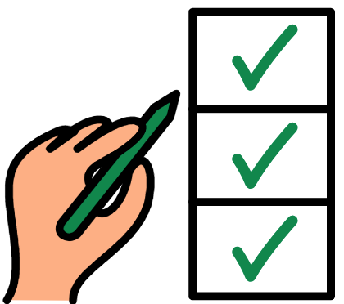
We will give women and girls with disabilities information they can understand about what was agreed at the meetings.
10

We will make sure that women and girls with disabilities can help to check how all the work from the meetings is going.

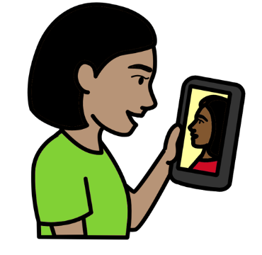
11
We will keep up to date with how to make things easy for people with disabilities to take part in.

We will ask women and girls with disabilities if the meetings were easy for them to take part in and what could be better.

We will make changes in the future if we need to.

12
We will make information and rules about how to make sure that women and girls with disabilities can take part in our meetings.

We will work with women and girls with disabilities to make the information and rules.

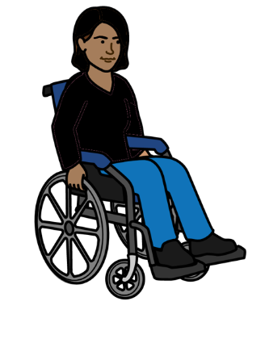
We will try to solve any problems that stop women and girls with disabilities from taking part in work to make the world fairer for women and girls.
13

That includes women and girls with disabilities who might find it harder to take part than others.
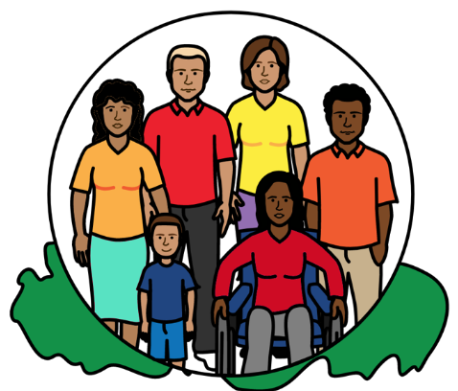

We will also work to make sure that all women and girls with disabilities in the world are treated fairly and get their human rights.

The Picture Communication Symbols ©1981–2016 by Mayer-Johnson LLC a Tobii Dynavox company. All Rights Reserved Worldwide. Thousands of resources available for free at www.boardmakeronline.com

