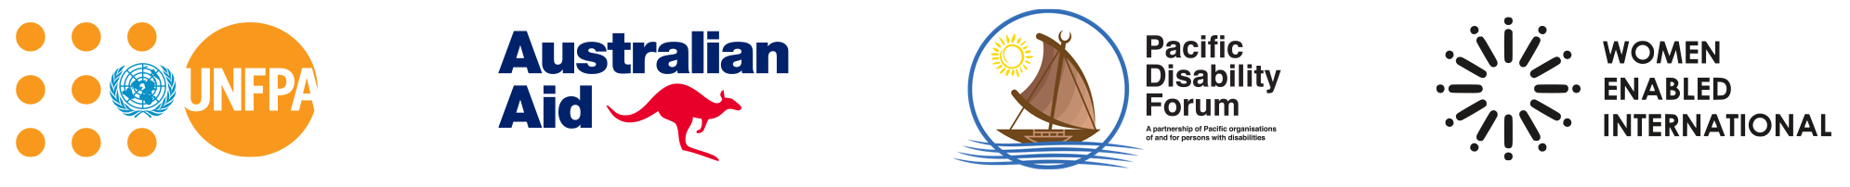
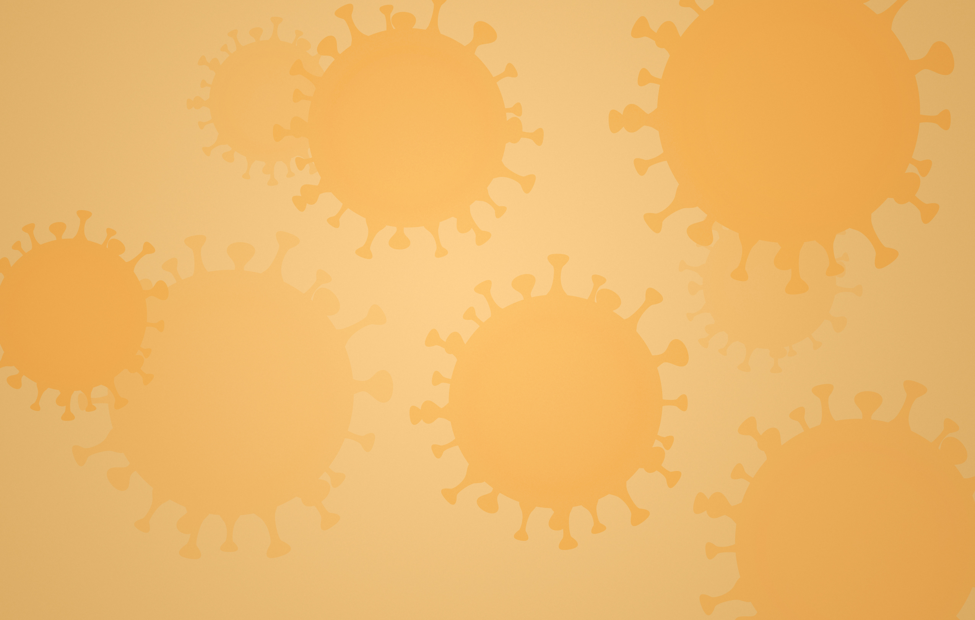
Women, Girls, and Gender Non-Conforming People with Disabilities — Know Your Rights!
Gender-based violence and sexual and reproductive health during the Covid-19 pandemic in the pacific region

What is Gender-Based Violence?
Gender-based violence is harm that happens to a person or a group of people because of their gender. Gender means whether someone acts and looks like what your community thinks a woman, a girl, a man, or a boy should act like or look like. Gender non-conforming people include people who do not act or look like what people would expect of women, girls, men, or boys in their communities. For example, in Samoa there is a third gender called Fa‘afafine. Fa‘afafine are people who identify themselves as having a third-gender or non-binary role in Samoa.
Although gender-based violence can happen to anyone, it most often happens to women and girls. Gender-based violence can take many forms including physical, emotional, psychological, sexual, and financial violence and abuse. It is about gender inequality, which means the way men and women are treated differently in a community. The acronym GBV is often used as a way to refer to gender-based violence.
For persons with disabilities, GBV can sometimes take unique forms like abuse by a support person; withholding of medication or an assistive device; or denial of necessities like food, money, and toileting support. Perpetrators—the people who commit this violence—can include intimate partners (like a girlfriend or a husband), family members, support staff, service providers, teachers, or the police. The Covid-19 pandemic has increased the number of people experiencing or at risk of GBV, particularly persons with disabilities.
Example: A man kicks his wife because he is unhappy that she did not prepare dinner for the family. In the man’s community, women are expected to prepare dinner each night for their families.
Example: A girl’s support person takes away her wheelchair when they are unhappy with her or want to force her to do something (like stay inside the house or give them money).

What is Sexual and Reproductive Health?
Sexual and reproductive health is health issues that have to do with your body, sex, relationships, and having and giving birth to children. This includes having the information you need to be able to make your own decisions about your body, when to have sex, and whether or not to become a parent. This also includes having access to family planning methods—or contraceptives—when you do not want to become pregnant. The acronym SRH is often used as a way to refer to sexual and reproductive health.
Many persons with disabilities find it hard to get the right healthcare, information, and support to be able to make decisions about their body, sex, relationships, and becoming parents. People often have mistaken beliefs about persons with disabilities and sex. For example, they may believe that a woman with a disability does not have sex, that she should not become a parent, or that she cannot make her own decisions about family planning and her body. As a result, doctors and family members sometimes make decisions about SRH for persons with disabilities, rather than letting them make decisions themselves. The Covid-19 pandemic has made it more difficult for people with disabilities to access SRH services, particularly where government lockdowns limit access to supports (including interpreters) and public transportation and restrict movement within the country.
Example: A nurse in the maternity ward verbally abused a woman with disability during labor, telling her that she should not have been so careless to get pregnant because she would not be able to take care of a child.
Example: A young Deaf woman could not communicate with her health care provider because the family planning clinic did not have sign language interpreters. As a result, she was not able to get information or ask questions about different contraceptive methods to understand what method is right for her.

What are my rights?
You have a right to be free from GBV. The government must prevent, protect, investigate, and punish GBV, and provide you access to a remedy if you experience violence.
You also have the right to health, including SRH. The government must make sure that SRH information, goods, and services are available, accessible, acceptable, and good quality.
These rights are protected in many international documents called treaties, which the government has ratified. This means the government has a duty to make sure you have those rights. Two important treaties for you to know about are the Convention on the Rights of Persons with Disabilities—also known as the CRPD—and the Convention on the Elimination of All Forms of Discrimination against Women—known as CEDAW.
Many countries in the Pacific region—including the Federated States of Micronesia, Fiji, Kiribati, Marshall Islands, Samoa, and Vanuatu, have ratified both treaties. Solomon Islands has ratified CEDAW and has signed, but not yet ratified, the CRPD. Tonga is not a party to either CRPD or CEDAW.

You have the right under these and other treaties:
- To be treated equally and without discrimination based on your gender or your disability.
- To make your own choices about your body, health, sex, and having children. This includes having a choice about if you want to have children and how many children to have, and to have access to the information, goods, and services to be able to make this decision.
- To access the police and the court system to seek justice.
- To information about GBV, SRH, and the Covid-19 pandemic in ways you can understand.
- To accessible services such as shelters, GBV hotlines, emergency services, and Covid-19 testing, treatment, and vaccination programmes.
What does it mean to be accessible?
Accessibility means that information, goods, and services can be used by persons with disabilities on an equal basis with non-disabled people. This means that, among other actions, the government must make sure that different information and communication formats are available (such as digital, braille, sign language, plain language, Easy-to-Read formats); that there are policy exceptions to allow service animals, interpreters, and support staff to accompany service recipients; that information, goods, and services are affordable, including with fee waivers; and that ramps, railings, and elevators are provided.
Example: Covid-19 testing sites are located in a building that is wheelchair-accessible.
Example: All public awareness campaigns on the TV about GBV, SRH, and Covid-19 include a sign-language interpreter.
- To protection and safety during emergencies - such as a global pandemic, a natural disaster, or a war or conflict.
- To live independently and to be included in your community—including access to support services to enable you to live independently with the supports you require.
- To health—including physical and psychological recovery from violence; sexual and reproductive health information, goods, and services; rehabilitation; and assistance reintegrating back into your community.
- To an adequate standard of living for yourself and your family and to social protection. The term ‘social protection’ means the government takes steps to make sure you and your family have access to the services you need—including being able to meet your basic needs such as having enough food, water, clothing, and fair housing.
- To be able to vote, express your opinion, and for persons with disabilities in general to be included in political processes.

Have my rights changed during the Covid-19 pandemic?
No! The government must respect, protect, and fulfil your right to be free from GBV and your right to SRH at all times. In fact, you have more rights now because you have rights during and after an emergency such as this pandemic. At all times, and particularly during the Covid-19 pandemic, the government must:

The government must respect your rights:
The government, and anyone who works for the government, are required to never commit GBV and to have laws in place making such violence illegal. The government also must not prevent people from accessing SRH services.
Example: You have the right to have the disability related support services you require to be classified as essential services. This right is important to enable you to live independently and to not have to rely on your family or institutional settings for essential support services and basic needs like food, water and housing

The government must protect your rights:
The government must protect persons with disabilities from GBV by acting to prevent and address GBV committed by private people (like your family member, support person, or partner). The government also has the obligation to protect your right to make your own decisions about your SRH of women and girls with disabilities, rather than letting private people make decisions for you.
Example: You have the right—even during Covid-19 lockdowns or stay-at-home orders—to leave your house to escape violence, seek help from the police, or access health and GBV services.
Example: You have the right to be included in and to be able to understand the information featured in any GBV Covid-19 awareness-raising campaigns addressing the increased risk of violence during Covid-19 restrictions and about available services.
Example: You have a right to be accompanied by a support person or interpreter to healthcare appointments, even where local regulations or health clinic or hospital rules limit patient accompaniment.

The government must fulfil your rights:
The government must make sure that people
with disabilities can live a life free from GBV, including, for example, by ensuring that protection services are accessible and by training service providers on disability-inclusive services. The government must also ensure the participation of women, girls, and gender non-conforming persons with disabilities in the Covid-19 preparation, response, and recovery process.
Example: Women, girls, and gender non-conforming persons with disabilities must be consulted in the government’s assessments of GBV during the Covid-19 pandemic and funding and programming assigned accordingly.
Example: Women, girls, and gender non-conforming persons with disabilities
must be included in the collection of data disaggregated by both gender and disability on the impact of Covid-19 on GBV.

Resources about counseling, gender based violence services, sexual and reproductive health services, and/or support from your local Organization of Persons with Disabilities (OPDs) in the Pacific region:
- Fiji
  - Fiji Disabled People’s Federation (FDPF) 331-1203
  - Women’s Crisis Center Helpline (24-hour, toll-free) 1560
  - Medical Services Pacific Child Helpline (toll-free) 1325
  - Medical Services Pacific Adult Counseling 5640
  - Lifeline Fiji Crisis Helpline (24-hour, toll-free) 132-454
  - Reproductive & Family Health Association Fiji 3306-175
- Kiribati
  - Te Toa Matoa 73046331
  - Child Protection Helpline 1113
  - Kiribati Women and Children Support Center 191, 75021000
- Samoa
  - Nuanua O Le Alofa (NOLA) 21147
  - Emergency Call Centre 911
  - Samoa Victim Support Group Helpline (24-hour, toll-free) 800-7874
  - The Ministry of Women, Community and Social Development 842-7752
  - Faataua le Ola Mental Health Support (24-hour, toll-free) 800-5433
  - Samoa Police 22222
  - Samoa Family Health Association 685 26929
- Solomon Islands
  - People with Disabilities Solomon Islands 25608
  - Domestic Violence Helpline (including weekends & public holidays) 8am–4:30pm 26999
4:30pm–8am 20619
  - GBV Hotline (24/7, toll-free) 132
  - Child Protection Helpline 20569
after hours 7522844
- Tonga
  - Nuanau O’ E’ Alamaite, Tonga Association 772 9007
  - Women and Children Crisis Centre Helpline (24-hour) 22240
- Vanuatu
  - Vanuatu Disability Promotion and Advocacy Association 37997
  - Women’s Centre Domestic Violence Helpline 24000
  - Vanuatu Police Emergency Line 111

Where can I learn more about my rights?
- UNFPA and Women Enabled International (WEI), Women and Young Persons with Disabilities: Guidelines for Providing Rights-Based and Gender-Responsive Services to Address Gender-Based Violence and Sexual and Reproductive Health and Rights (2018).
- UNFPA and WEI, Covid-19, Gender, and Disability Checklist: Ensuring Human Rights-Based Sexual and Reproductive Health for Women, Girls, and Gender Non-conforming Persons with Disabilities during the Covid-19 Pandemic (2021).
- UN Women and WEI, Covid-19, Gender, and Disability Checklist: Preventing and Addressing Gender-Based Violence against Women, Girls, and Gender Non-conforming Persons with Disabilities during the Covid-19 Pandemic (2021).
- Pacific Disability Forum, et al., Toolkit on Eliminating Violence Against Women and Girls with Disabilities in Fiji (2014).

This publication was produced by Women Enabled International (WEI), in partnership with the United Nations Population Fund – Pacific Sub-Regional Office (UNFPA-Pacific) and the Pacific Disability Forum (PDF), as part of the Transformative Agenda for Women, Adolescents and Youth in the Pacific. The Transformative Agenda programme is funded by the Australian Government and implemented by UNFPA.
This publication has been funded by the Australian Government through the Department of Foreign Affairs and Trade and support from the United Nations Population Fund (UNFPA). The views expressed in this publication are the author’s alone and are not necessarily the views of the Australian Government or UNFPA.

Endnotes

UN Women, Frequently Asked Questions: Types of Violence against Women and Girls (2021), https://www.unwomen.org/en/what-we-do/ending-violence-against-women/faqs/types-of-violence.
WHO, Gender and Health (2021), https://www.who.int/health-topics/gender#tab=tab_1.
See, e.g., Human Rights Campaign, Glossary of Terms, https://www.hrc.org/resources/glossary-of-terms?utm_source=GS&utm_medium=AD&utm_campaign=BPI-HRC-Grant&utm_content=454853592927&utm_term=lgbt%20definition&gclid=Cj0KCQiAvvKBBhCXARIsACTePW-cHrQEQk0ockKXIUklmDzb__pARvs_nQeD-vN6vlFUjinbddeTHzgaAotsEALw_wcB.
Reuters, Samoa’s ‘third gender’ delicately balances sex and religion (2019), https://www.reuters.com/article/us-pacific-samoa-gender/samoas-third-gender-delicately-balances-sex-and-religion-idUSKCN1UQ036.
See, e.g., Council of Europe, What is gender-based violence?, https://www.coe.int/en/web/gender-matters/what-is-gender-based-violence.
UN Women, Frequently Asked Questions: Types of Violence against Women and Girls (2021), https://www.unwomen.org/en/what-we-do/ending-violence-against-women/faqs/types-of-violence.
See, e.g., Committee on the Rights of Persons with Disabilities (CRPD Committee), General Comment No. 3: Women and girls with disabilities, para. 31, U.N. Doc. CRPD/C/GC/3 (2016).
UNFPA & Women Enabled International (WEI), Women and Young Persons with Disabilities: Guidelines for Providing Rights-Based and Gender-Responsive Services to Address Gender-Based Violence and Sexual and Reproductive Health and Rights 49-51 (Nov. 2018) [hereinafter UNFPA AND WEI] https://www.unfpa.org/featured-publication/women-and-young-persons-disabilities.
UN Women, Covid-19 and Ending Violence Against Women and Girls 1-2 (2020), https://www.unwomen.org/-/media/headquarters/attachments/sections/library/publications/2020/ issue-brief-Covid-19-and-ending-violence-against-women-and-girls-en.pdf?la=en&vs=5006.
Emma Pearce, Disability Considerations in GBV Programming during the Covid-19 Pandemic (Mar. 2020), http://www.sddirect.org.uk/media/1889/gbv-aor-research-query_Covid-19-disability-gbv_final-version.pdf.
UNFPA, Sexual and reproductive health, https://www.unfpa.org/sexual-reproductive-health.
Id.
Id.
UNFPA AND WEI, supra note 8, at 92.
Id., at 103.
WEI, Covid-19 at the Intersection of Gender and Disability: Findings of a Global Human Rights Survey (2020), https://womenenabled.org/pdfs/Women%20Enabled%20International%20COVID-19%20at%20the%20Intersection%20of%20Gender%20and%20Disability%20May%202020%20Final.pdf.
See, e.g., Focus Group Discussion by Naomi Navoce with members of the United Blind Persons of Fiji, in Suva, Fiji (Sept. 25, 2020); Focus Group Discussion by Naomi Navoce with members of the Fiji Association of the Deaf, in Suva, Fiji (Nov. 26, 2020); Focus Group Discussion by Naomi Navoce with members of the Nadi and Lautoka Branches of the Fiji Disabled People’s Federation, in Nadi, Fiji (Jan. 13, 2021).
CEDAW Committee, General Recommendation No. 19: Violence against women, U.N. Doc. HRI/GEN/1/Rev.9 (Vol. II) (1992).
Convention on the Rights of Persons with Disabilities, G.A. Res. 61/106, art. 25, U.N. Doc. A/RES/61/106 (Dec. 13, 2006) ) [hereinafter CRPD]. Learn more here: https://www.un.org/development/desa/disabilities/convention-on-the-rights-of-persons-with-disabilities.html.
Convention on the Elimination of All Forms of Discrimination against Women, adopted Dec. 18, 1979, G.A. Res. 34/180, U.N. GAOR, 34th Sess., Supp. No. 46, at 193, U.N. Doc. A/34/46, U.N.T.S. 13 (entered into force Sept. 3, 1981) ) [hereinafter CEDAW]. Learn more here: https://www.un.org/womenwatch/daw/cedaw/.
International Covenant on Civil and Political Rights, adopted Dec. 16, 1966, art. 2, G.A. Res. 2200A (XXI), U.N. GAOR, 21st Sess., Supp. No. 16, U.N. Doc. A/6316 (1966), 999 U.N.T.S. 171 (entered into force Mar. 23, 1976) [hereinafter ICCPR]; International Covenant on Economic, Social and Cultural Rights, art. 2, G.A. Res. 2200A (XXI), U.N. GAOR, Supp. No. 16, U.N. Doc. A/6316 (1966) [hereinafter IESCR]; CRPD, arts. 5-7; CEDAW, arts. 1, 3; Convention on the Rights of the Child, adopted Nov. 20, 1989, arts. 2, 5, G.A. Res. 44/25, annex, U.N. GAOR, 44th Sess., Supp. No. 49, U.N. Doc. A/44/49 (1989) (entered into force Sept. 2, 1990) [hereinafter CRC.
ICESCR, art. 14; CEDAW, arts. 12, 16; CRPD, arts. 12, 25. See also, Committee on Economic, Social, and Cultural Rights (ESCR Committee), General Comment No. 22 (2016) on the Right to Sexual and Reproductive Health (Article 12 of the International Covenant on the Economic, Social and Cultural Rights, paras. 12-21, U.N. Doc. E/C.12/GC/22 (May 2016).
ICCPR, art. 26; CRPD, arts. 12, 13.
CRPD, art. 8.
CRPD, art. 9.
CRPD Committee, General Comment No. 2: Article 9: Accessibility, para. 13, U.N. Doc. CRPD/C/GC/2 (2016).
Id., paras. 20, 27-33.
CRPD, art. 11.
CRPD, art. 19.
CRPD, arts. 16(4), 25; CRC, art. 39.
ICESCR, art.11; CRPD, art. 28.
ICESCR, art.11; CRPD, art. 28.
ICESCR, art.11; CRPD, art. 28.
CRPD, art. 29.
CRPD, arts. 16, 25.
See Vienna Convention on the Law of Treaties, art. 26, 1155 U.N.T.S. 331 (1980); Human Rights Committee, General Comment No. 35: Article 9 (Liberty and security of person), para. 9, U.N. Doc. CCPR/C/GC/35 (2014); CRPD Committee, General Comment No. 3, supra note 7, para. 25, U.N. Doc. CRPD/C/GC/3 (Nov. 25, 2016).
ESCR Committee, General Comment No. 22, supra note 22, paras. 12-21, 39-48.
See Vienna Convention on the Law of Treaties, art. 26; Human Rights Committee, General Comment No. 31: Nature of the General Legal Obligations Imposed on States Parties to the Covenant, para. 8, U.N. Doc. CCPR/C/21/Rev.1/Add.13 (2004); Human Rights Committee, General Comment No. 35, supra note 37, para. 9; CRPD Committee, General Comment No. 3, supra note 7, para. 26; ESCR Committee, General Comment No. 22, supra note 22, para. 41.
See Vienna Convention on the Law of Treaties, art. 26; ESCR Committee, General Comment No. 22, supra note 22, paras. 42, 48; CRPD Committee, General Comment No. 3, supra note 7, para. 27.
CRPD, art. 11.

