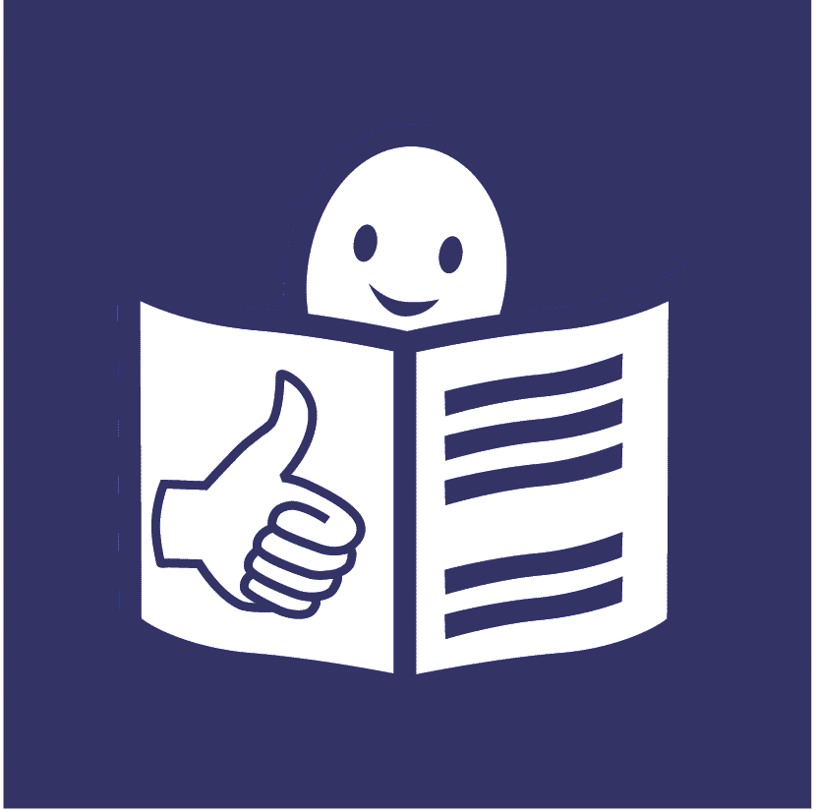

Easy read

Life for women and girls with disabilities in the world during COVID-19

COVID-19 is a new illness that many people in the world have been getting. It is sometimes called Coronavirus

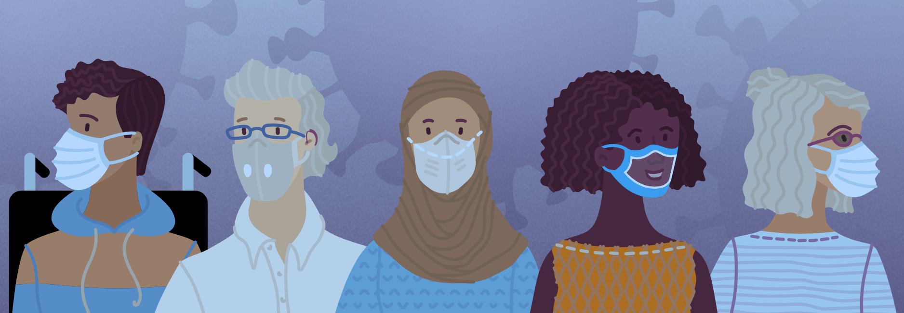

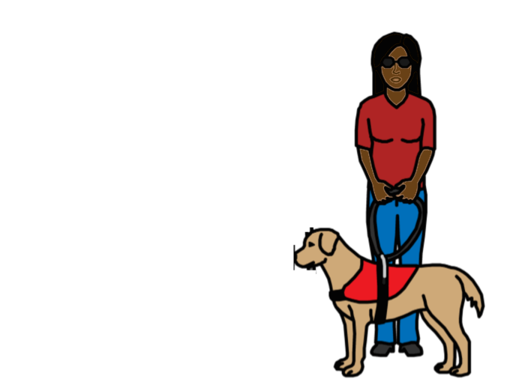
About this report
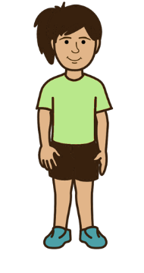

This report is about life for women and girls with disabilities in the world during COVID-19.

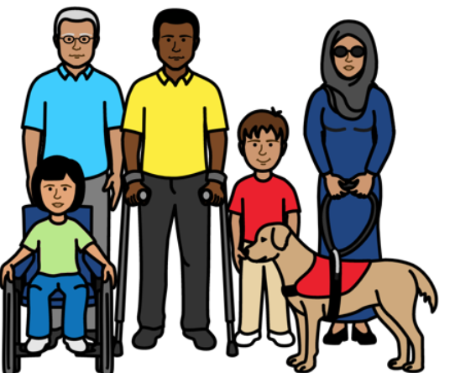

We are a group of organisations that work around the world.

We support the rights of women and girls and people with disabilities.
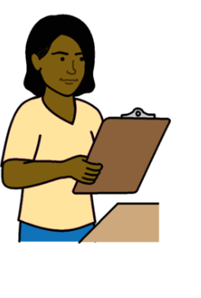

In 2020 we looked at what was happening to women and girls with disabilities during COVID-19.
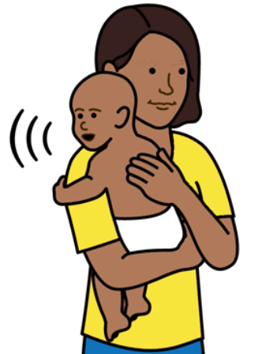

We looked at the rights of women and girls with disabilities to do with their bodies, sex, relationships
and having children.
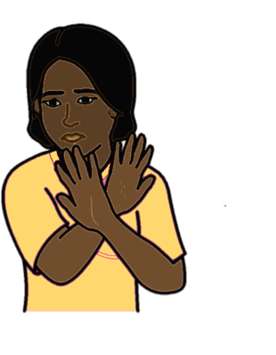
We also looked at their right to be safe from violence.

We got information from many people to write this report.
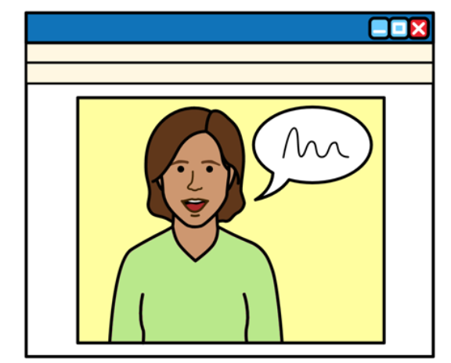
This includes:

- Women, girls and other people with disabilities

- People who support people with disabilities

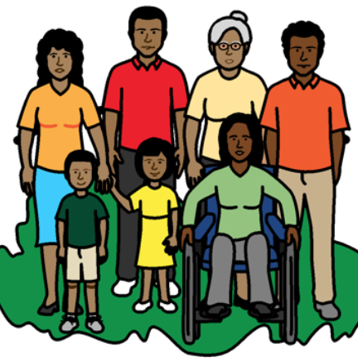

When we say women and girls with disabilities we also mean people with disabilities who are not the gender that people say they are.

Gender is about being a woman, a girl, a man, a boy or someone else.

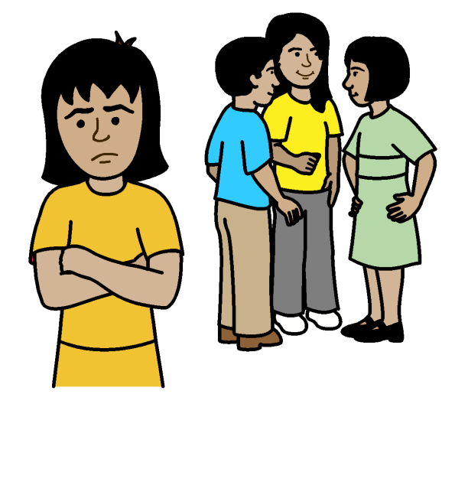
What we found out

Life has been hard for many women and girls with disabilities in the world during COVID-19.

They have often been left out.

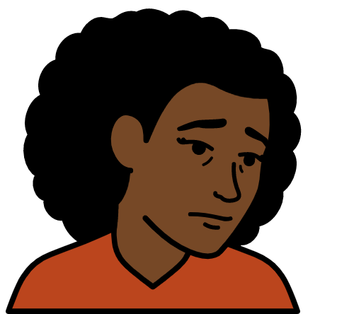

This was already a problem before COVID-19.

But it got worse during COVID-19.

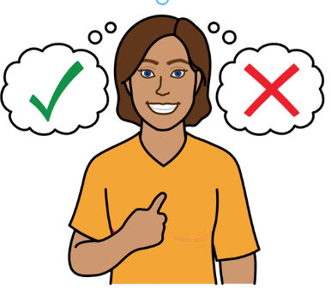
Support for women and girls with disabilities to do with their bodies, sex, relationships and having children

Women and girls with disabilities should get the right support to make their own choices about their lives.

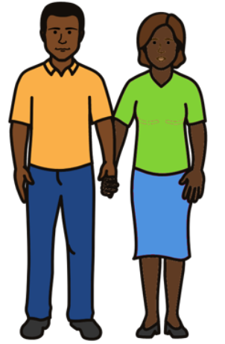
This includes information and health care to do with:
- Safe sex and relationships
- Choosing if they want children or not
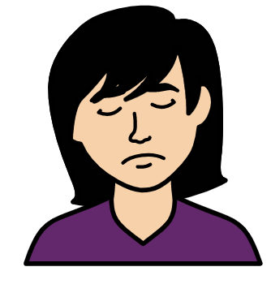

Many women and girls with disabilities found it harder to get the right support during COVID-19.

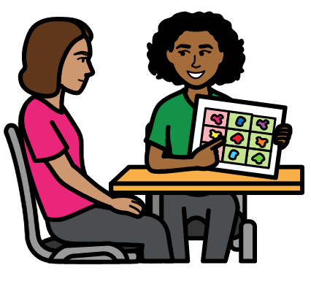
For example:

Women and girls with disabilities might need someone with them at health appointments.

For example, they might need someone who knows sign language or other ways to communicate.
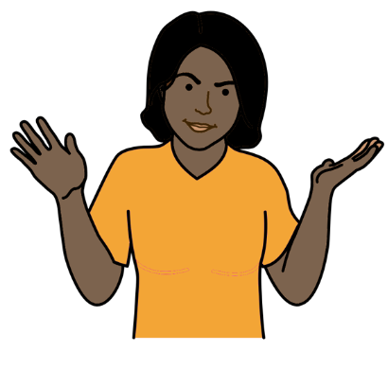

But many women and girls with disabilities could not bring anyone with them during COVID-19.

Some local health services closed during COVID-19.
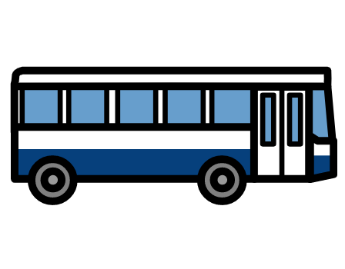

But transport was often hard to use or it cost too much.

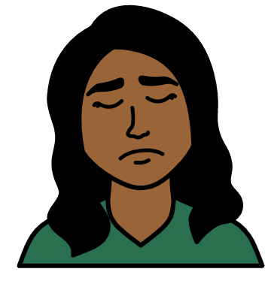

This meant that many women with disabilities could not travel to other health places to get support.
This put some women in danger.

Keeping safe from violence

Many women and girls with disabilities were more at risk of violence during COVID-19.
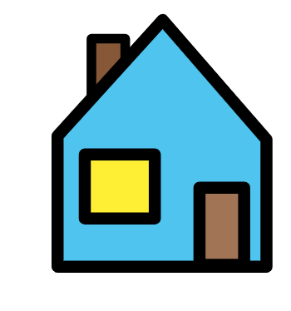

For example:

Many people had to stay at home with their families during COVID-19.

They could not go out.
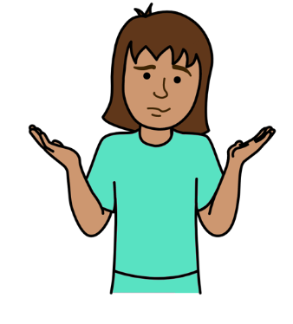
Many women and girls with disabilities stopped getting their usual support in the community for a while.

This was hard for many women and girls with disabilities and their families.
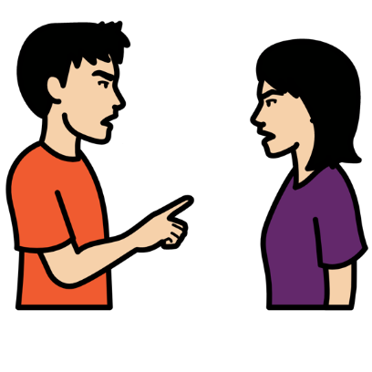

More violence might have happened to women and girls with disabilities because of that.

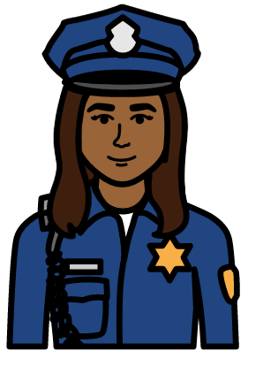

It was harder for women and girls with disabilities to get support if violence happened to them.

For example, support from the police and courts.

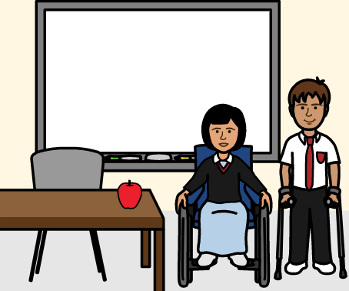

Many women and girls with disabilities found it hard to get other things they need during COVID-19.
Like education, food, clean water and work.
An example of life for women with disabilities during COVID-19

This is an example of what happened to women with disabilities in one part of England.

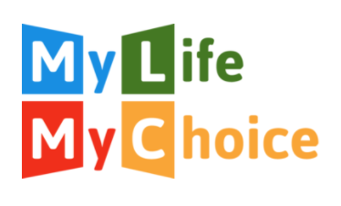

In 2020 we worked with an organisation of women with learning disabilities in England.

It is called My Life, My Choice.

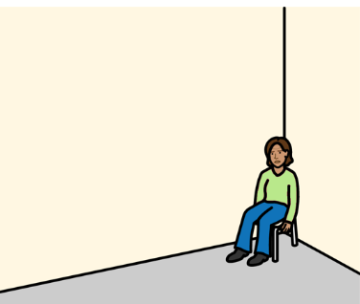

Here are the main things they told us:

It was hard staying at home a lot because of COVID-19.

It made some women very worried and sad.

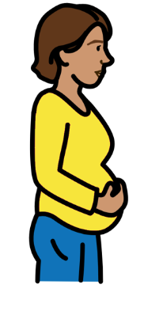
Some women found it hard to get support to do with their bodies, sex, relationships and having children.

This includes health care and information.

This happened to some people before COVID-19.

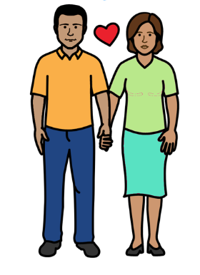

But most women got some health care, information and support.

For example, support with safe sex.

Many women and girls with disabilities in the world did not get this support.

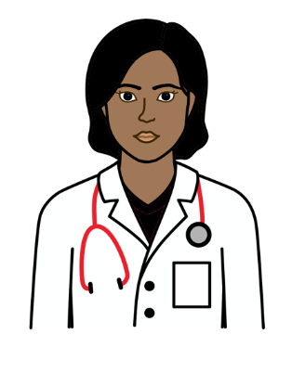

But COVID-19 made it harder to get some support.

For example, two women needed important information from their doctor.

But they could not talk to their doctor when they needed to.
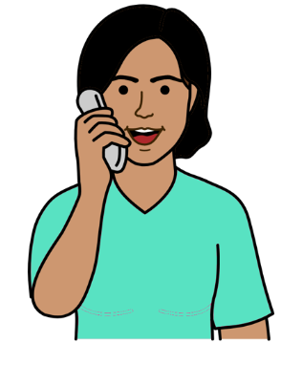
But the women could get some information about their bodies, sex and relationships from other places.

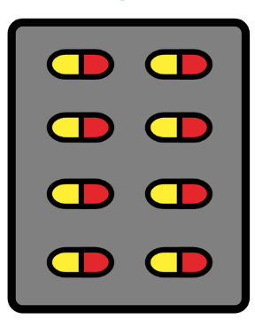
Some women had other health care problems during COVID-19.

For example:

- Problems getting medicine from the doctor in the same way
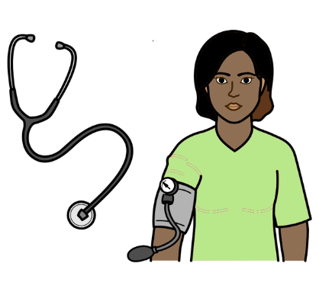

- Problems getting some health checks they needed from the doctor.

For example, checks for their blood pressure

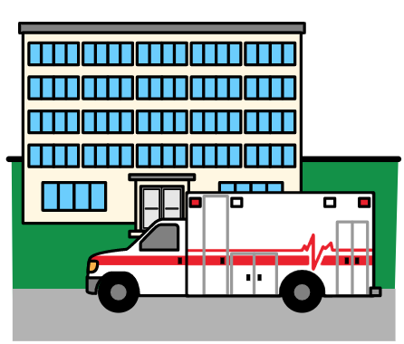

There were big problems with health care in England during COVID-19.

This was because many people got COVID-19.
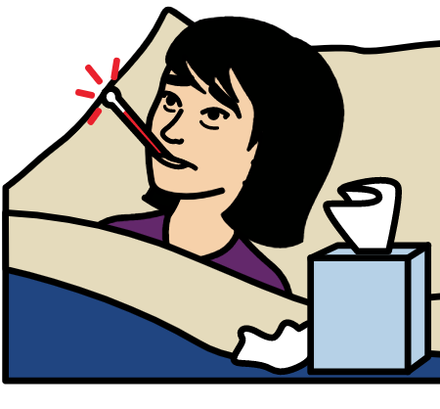
Things were often worse for people with disabilities.

For example, many people with learning disabilities got ill from COVID-19.
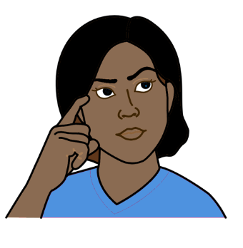

People said that there might be many reasons for that.

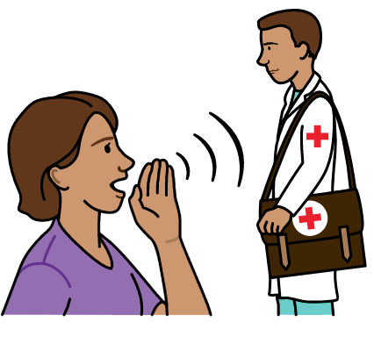
For example:

People with learning disabilities might find it hard to understand and talk to doctors and nurses in hospital.

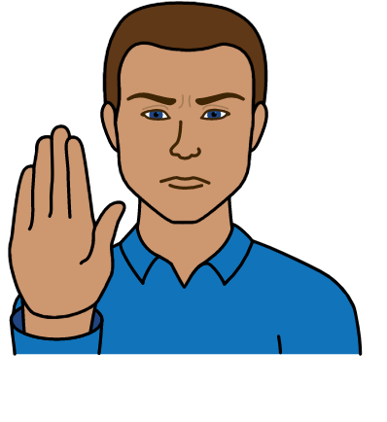

But many people with learning disabilities in hospital could not get support from family or friends.

They could not visit during COVID-19.

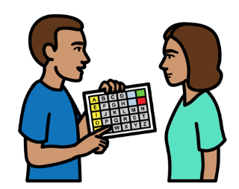
Some support staff could not visit people with learning disabilities for a while during COVID-19.

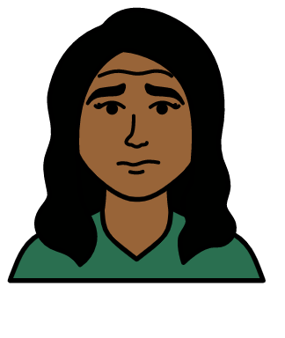

This meant that some people with learning disabilities did not get the support they need.

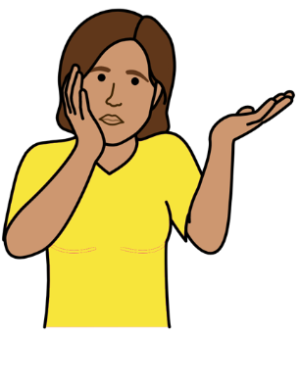

People said that they found information from the government about COVID-19 hard to understand.

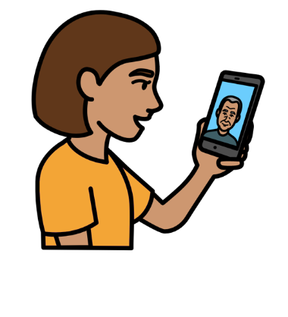

They had to ask people who support them for information instead.

What countries and other organisations should do
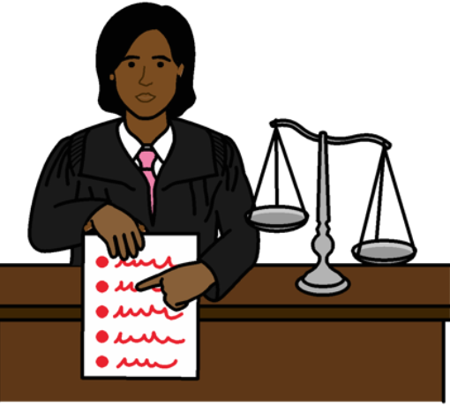

- Follow laws and rules in the world about the rights of women and girls with disabilities.

This includes rules about what to do when big problems happen in the country.

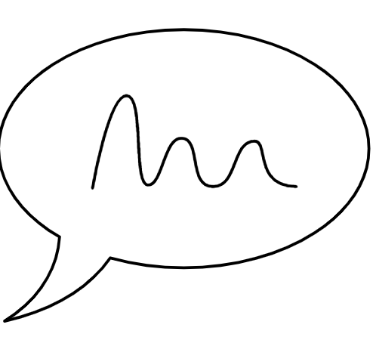
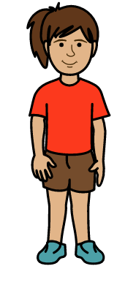
- Work with women and girls with disabilities to make laws and plans about what to do when there are big problems in the country.

This is to make sure that laws and plans work well for them.
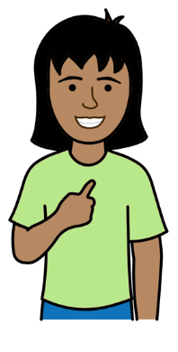

- Make sure that women and girls with disabilities are always treated fairly.

They should get all their rights now and in the future.
Most pictures by The Picture Communication Symbols ©1981–2016 by Mayer-Johnson LLC a Tobii Dynavox company. All Rights Reserved Worldwide. Thousands of resources available for free at www.boardmakeronline.com. Map picture by Photosymbols www.photosymbols.com

