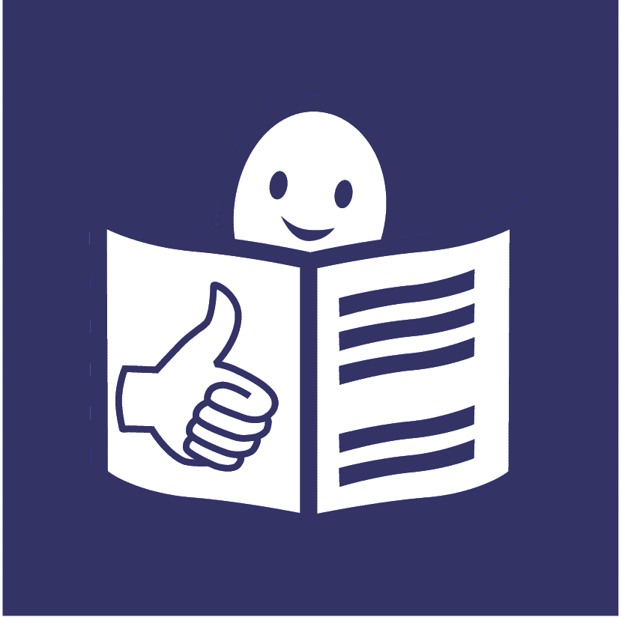

Easy read

Some good examples of women and girls with disabilities getting their rights during COVID-19

COVID-19 is a new illness that many people in the world have been getting. It is sometimes called Coronavirus.

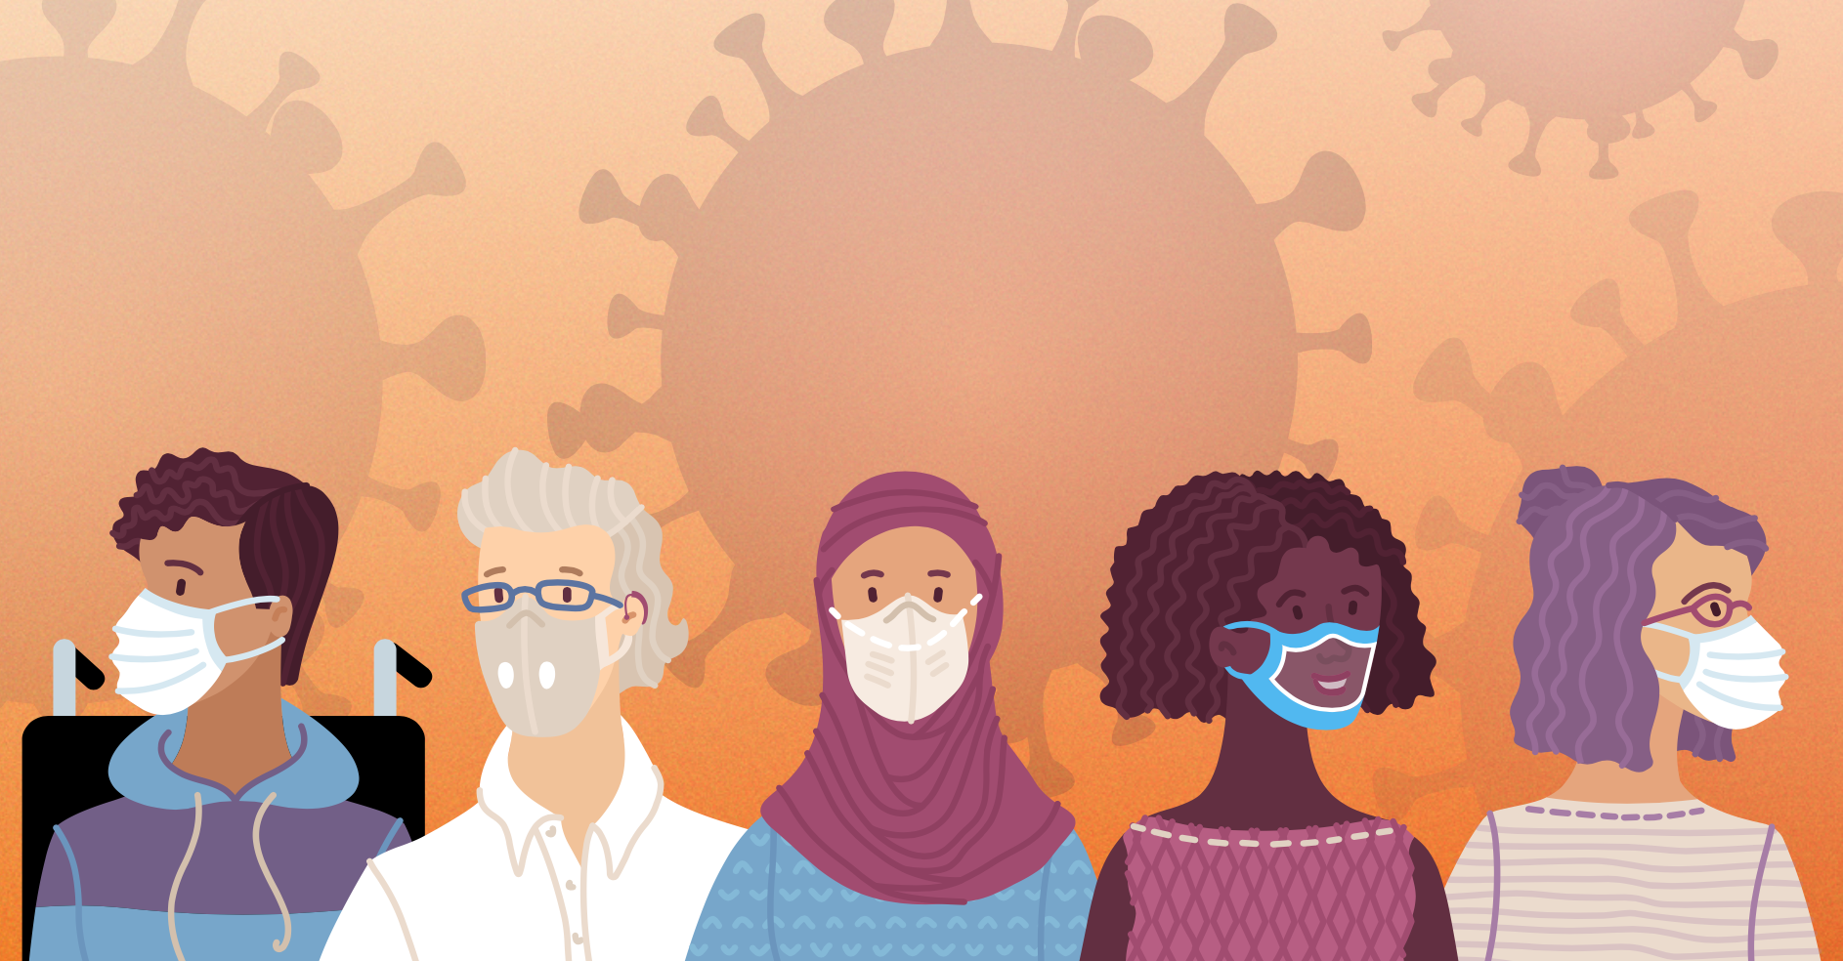

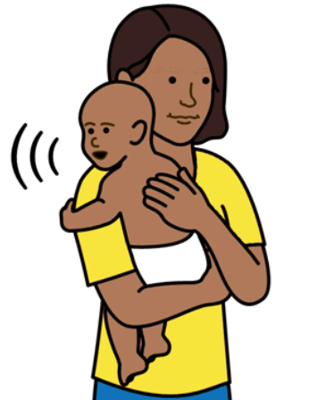
About this report

This report is about the rights of women and girls with disabilities during COVID-19.

It is about their rights to do with their bodies, sex, relationships and having children.
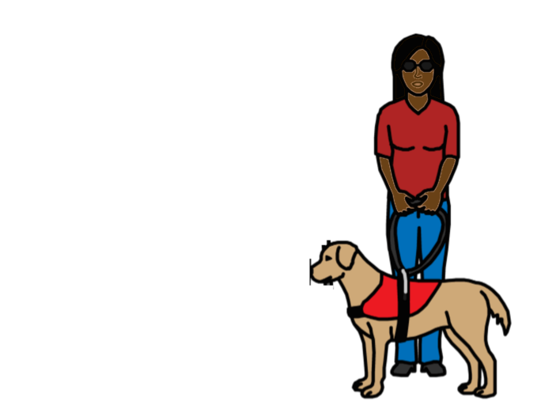
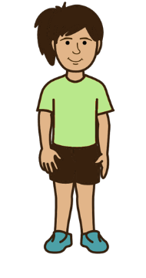

This report has some good examples of women and girls with disabilities getting their rights during COVID-19.

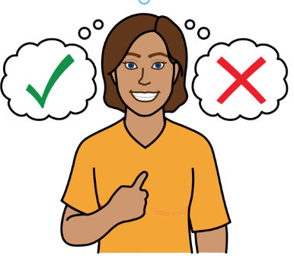

All women and girls with disabilities have the right to get good support to do with their bodies, sex, relationships and having children.

This includes health care and information.

And support to make their own choices.
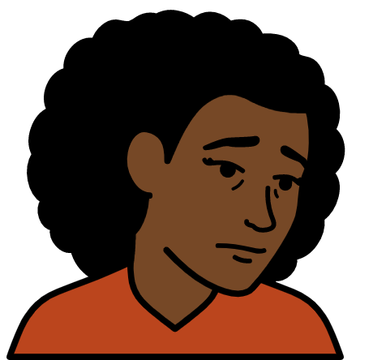

But many women and girls with disabilities do not get their rights.

This was a problem before COVID-19.
But it got worse during COVID-19.
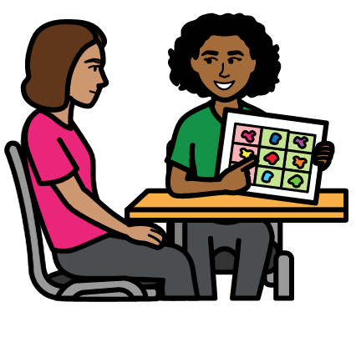
But some governments and organisations made sure that women and girls with disabilities could still get their rights during COVID-19.

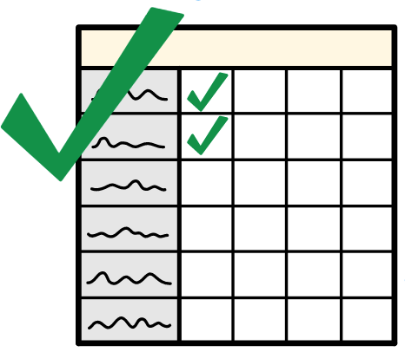

This report has some examples of good support for women and girls with disabilities during COVID-19.

The examples are from different places around the world.
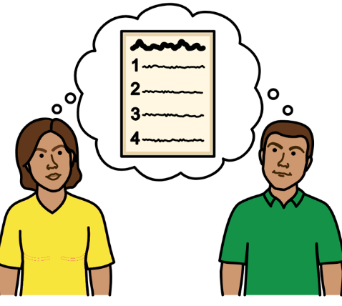

We hope that other governments and organisations can learn from the examples.

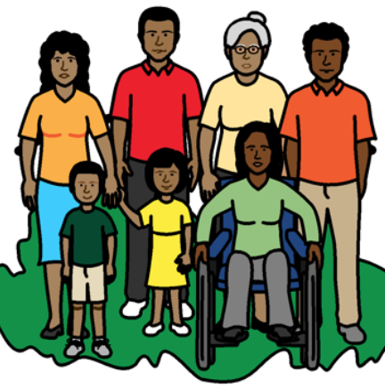

When we say women and girls with disabilities we also mean people with disabilities who are not the gender that people say they are.

Gender is about being a woman, a girl, a man, a boy or someone else.
Some good examples of women and girls with disabilities getting their rights during COVID-19

The rights are to do with their bodies, sex, relationships and having children

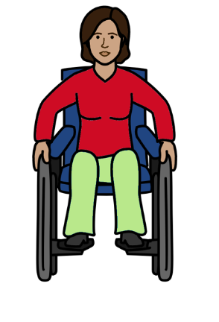
Making health services good and easy to use

The government in Tajikistan and other organisations started a new project during COVID-19.

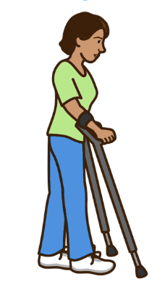
The project gave free health care to women and girls with disabilities.
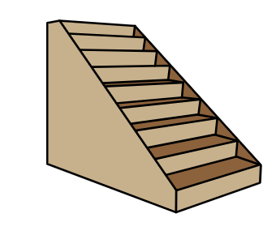

Many health care places were hard for women and girls with disabilities to use.

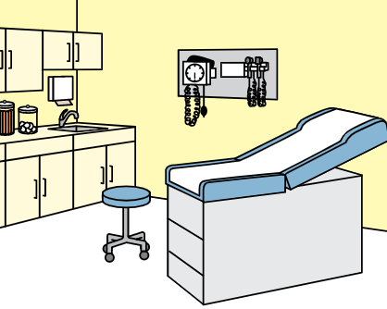

So the project built 5 new places in local areas.
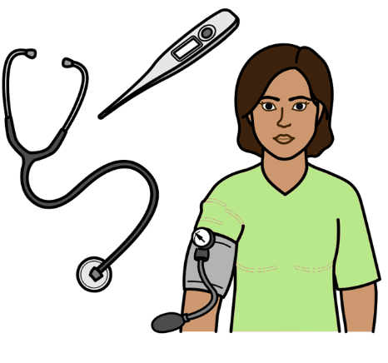
The new places give women and girls with disabilities lots of health care and advice.

For example:

- Medical tests to see if they have some health problems
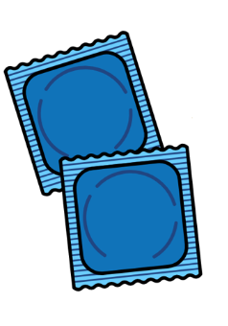
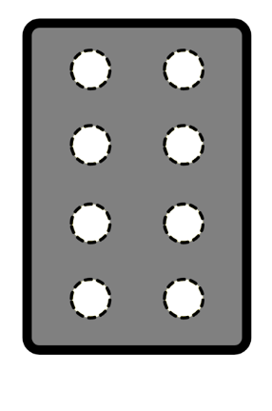

- Pills, condoms or other things to stop them getting pregnant if they want that

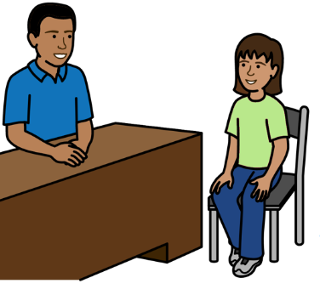
- Advice to do with being healthy, safe sex and having children

- Support to feel OK if they are sad or worried. For example, if someone is violent to them
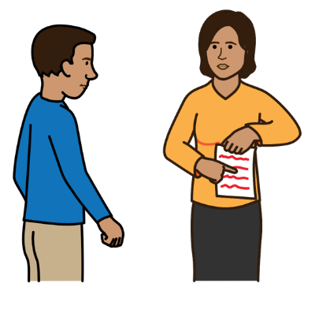

There has also been new information and training for doctors and nurses.

This is to help them know about the rights of women and girls with disabilities and how to treat them fairly.
Women with disabilities supporting each other

A group of women with disabilities in Guatemala met on the internet during COVID-19.
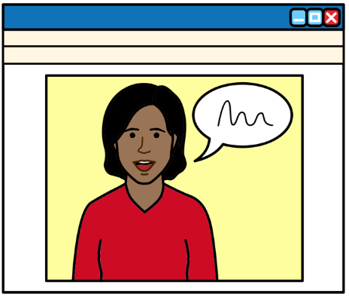

The group could not meet in person during COVID-19.

So they met on the internet instead.

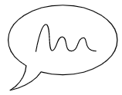
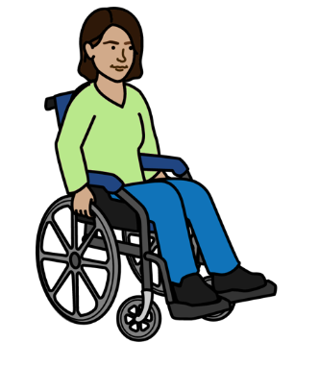

Meeting on the internet helped the women to talk about new and important things.

For example, things to do with their bodies, sex, relationships and children.
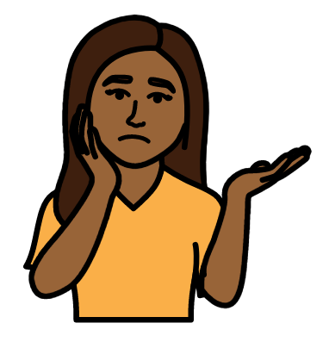

The women got support to meet on the internet if they needed it.

For example, some women did not know how to meet on the internet before that.
Keeping safe from violence
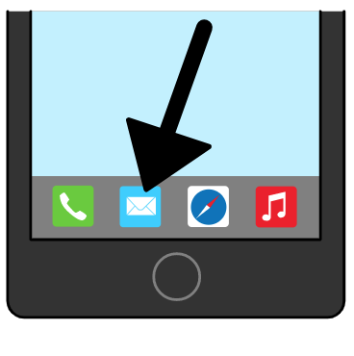

An organisation in Sri Lanka is making a new app for women with disabilities to use.

An app is something that is put on a mobile phone.

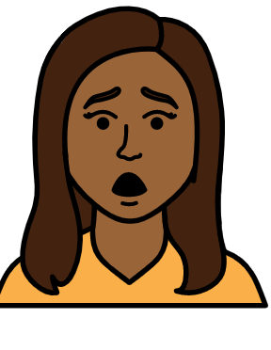

The app is for women with disabilities who need help quickly.

For example, if someone is violent to them.

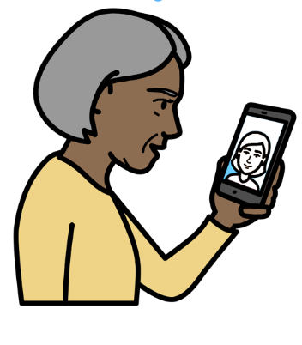

The app tells women where to get help. For example, from the police or hospitals.

Information on the app is easy to understand.

For example, there is information in sign language and easy words.
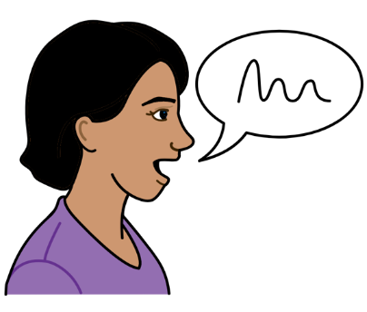
A project in Spain also helped women with disabilities to speak up about violence that happens to them.

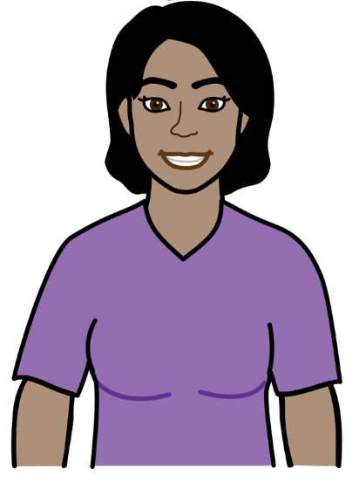

Women with disabilities helped with the project.

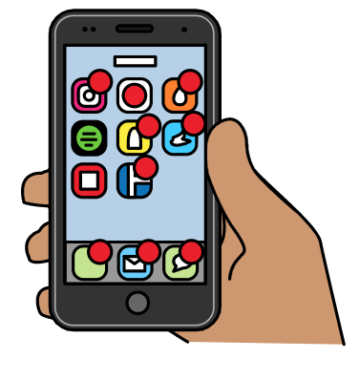

The project helped people to use social media to speak up about violence.

Social media is things like Twitter and Facebook.
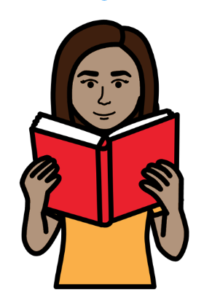

Women with disabilities also helped to make a document about stopping the violence.

The document was in easy words with pictures.

Looking at everything that women and girls with disabilities need
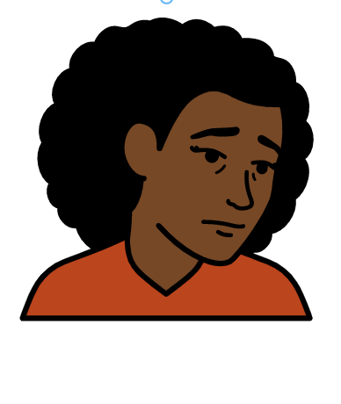

Many women and girls with disabilities in Kenya found life hard during COVID-19.

For example, they found it hard to get information, food and other things they needed.

Some organisations in Kenya have been supporting many women and girls with disabilities.

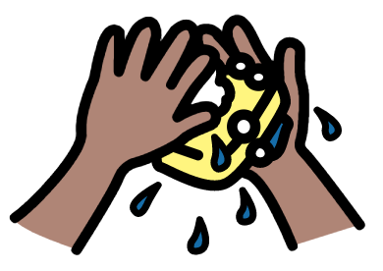
The support includes:

- Extra money to live on

- Things that girls with disabilities need. Like soap and things for their periods
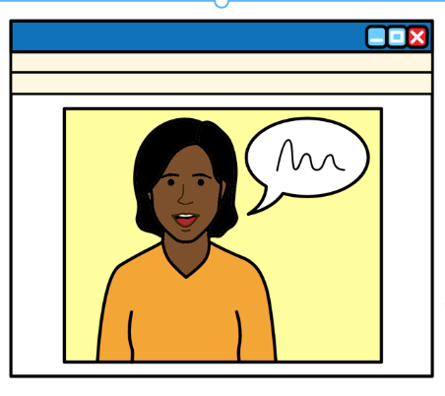

Women with disabilities also got support to meet and learn things on the internet.

This helped women with disabilities to learn new skills and support each other.
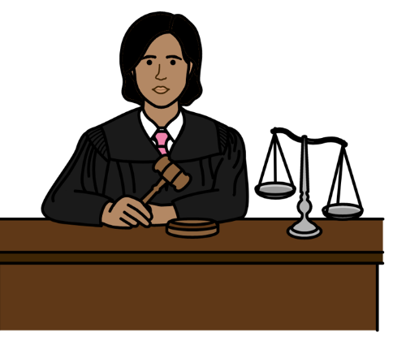
Making good laws

In 2020 Pakistan made a law to support the rights of people with disabilities.
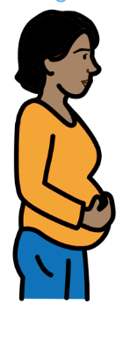

For example, the law says that:

Women with disabilities should get free health care to do with sex and having children.
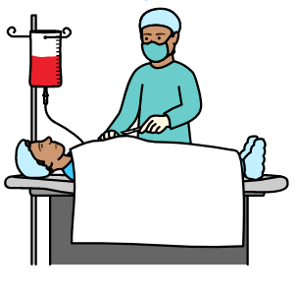

Women with disabilities must not be forced to have medical treatment to stop them having children.

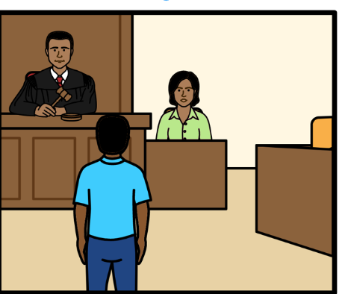

There should be better support for women and girls with disabilities if violence happens to them.

For example, advice and money to help them go to court.

To find out more

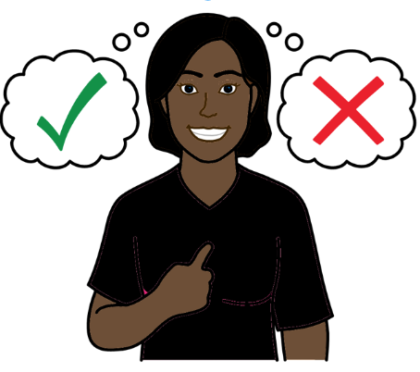

There are more documents about the rights of women and girls with disabilities to do with their bodies, sex, relationships and having children.

The documents are in easy words and pictures.

You can find them on these websites:

https://www.unfpa.org/resources/young-persons-disabilities-easy-read-report

This document is about the rights of women and girls with disabilities during COVID-19:

https://www.unfpa.org/resources/easy-read-covid-19-gender-and-disability-checklist-making-sure-people-disabilities-get

Pictures by The Picture Communication Symbols ©1981–2016 by Mayer-Johnson LLC a Tobii Dynavox company. All Rights Reserved Worldwide. Thousands of resources available for free at www.boardmakeronline.com.

