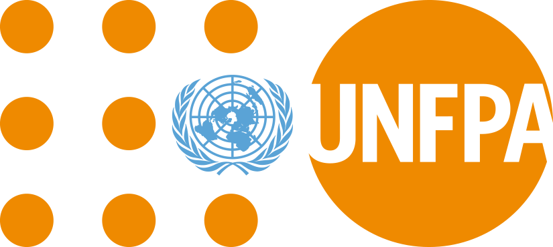

Making sure that people with disabilities get the right health care to do with their bodies, sex, relationships and having children during COVID-19

COVID-19 is a new illness that many people in the world are getting
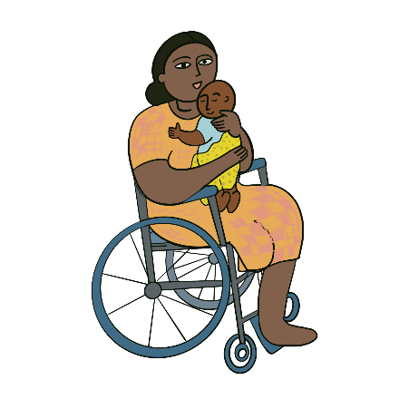

About this information
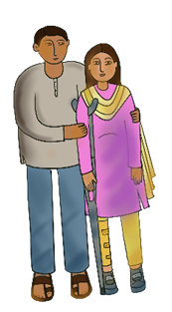

This information is about health care for people with disabilities to do with
their bodies, sex, relationships and having children.

For example, the health care might help people to give birth or have safe sex and relationships.
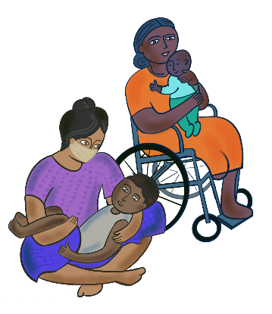

This information is about making sure that people with disabilities can get this health care during COVID-19.

And when other big problems happen in the world.

People with disabilities have a right to get this healthcare like everyone else.

But they are often left out.

And COVID-19 has made things worse.
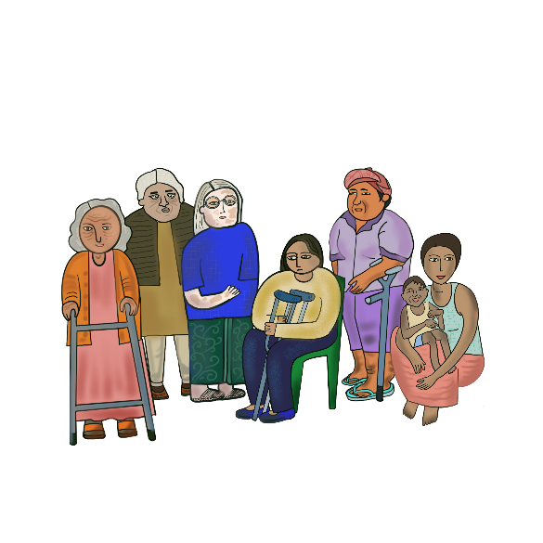
This information is about what countries and organizations should do now for people with disabilities.

We found out what many people with disabilities thought first.

People with disabilities in this document means women and girls with disabilities.

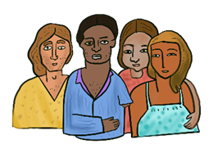
It also means people with disabilities who are not the gender that people said they were when they were born.

Gender means whether someone is a woman, a girl, a man, a boy or something else.

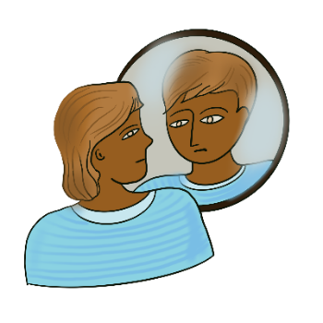

For example, someone may be told they are a boy because of how their body looks.

But that is not who they really are. They might be a girl. Or they might not be a boy or girl.

The main things that countries and organizations need to do

Make sure that people with disabilities can still get health care to do with their bodies, sex, relationships and having children during COVID-19
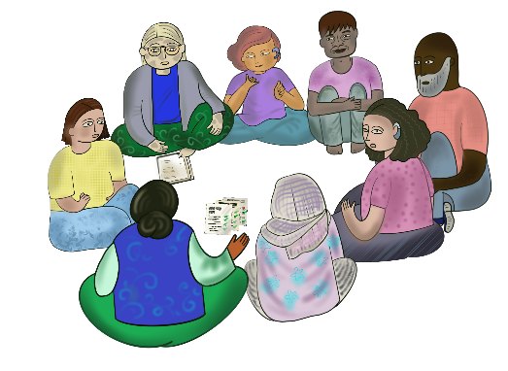

The main things to do

Work with people with disabilities to make laws and plans about health care during COVID-19.

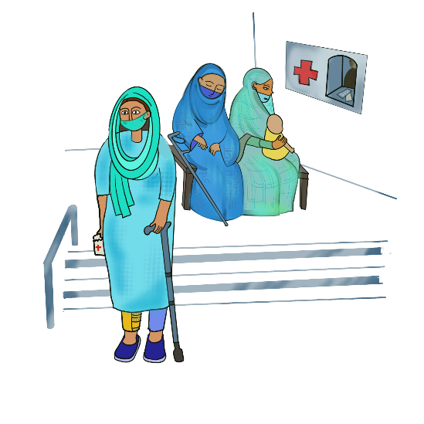
Make sure the health care is:

- Good

- Easy for people with disabilities to get

- Right for people with disabilities and what they need.
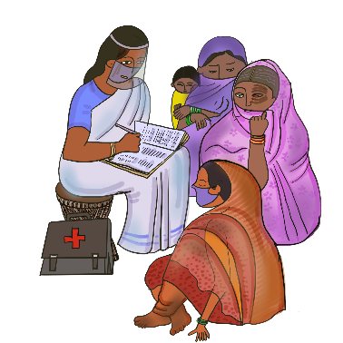
Check that people with disabilities are getting health care to do with their bodies, sex, relationships and having children during COVID-19.

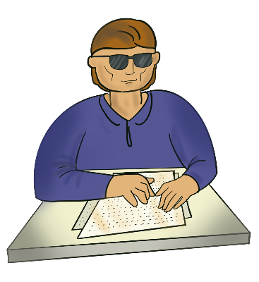
Make sure people with disabilities get information they can understand about:
- Health care, money and support they can get during COVID-19

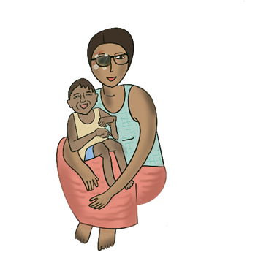
- Their rights to do with their bodies, sex, relationships and having children.

Make sure people who live in the countryside learn about this as well.

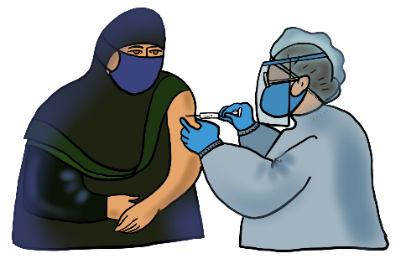
Make sure health workers can still work during COVID-19.

They should have the right support to work.

For example, face masks and gloves to keep everyone safe.

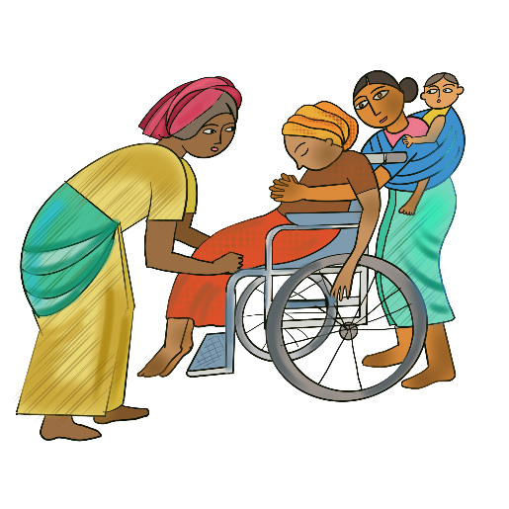
People with disabilities can still take a support person with them when they go to health appointments.
Or when they have a baby.

They can still do this during COVID-19.

Make sure that health workers and people with disabilities know that they can have someone with them.

It may not be safe to go to health appointments during COVID-19.
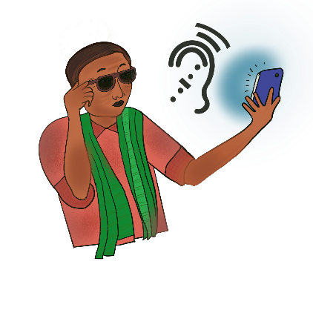

Make sure that people with disabilities can get good health care in other ways.

For example:

- By phone

- On the internet if that works well for people with disabilities.

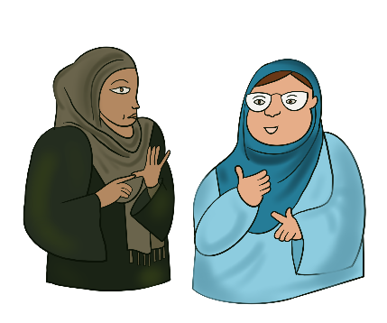
Make sure people with disabilities get support to take part in health appointments if they need it.

For example, support to communicate in sign language.

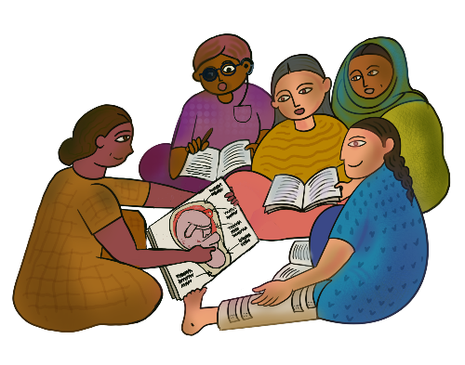

Make sure people with disabilities at school learn about their bodies, sex, relationships and giving birth.

They should learn in a way they find easy to understand.

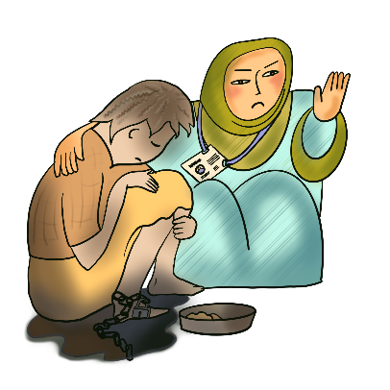
Make sure health services support people with disabilities to get help if someone is violent to them.

For example, make sure people with disabilities can tell someone in private.
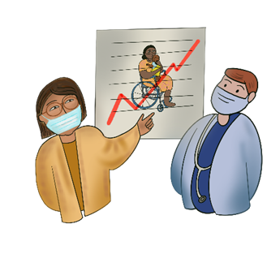

And give health workers the right training to support people with disabilities.

Make sure people with disabilities get other support they need to keep safe and well during COVID-19

The main things to do

Make sure people with disabilities get other things they need for COVID-19.

This includes good tests and treatment for COVID-19.

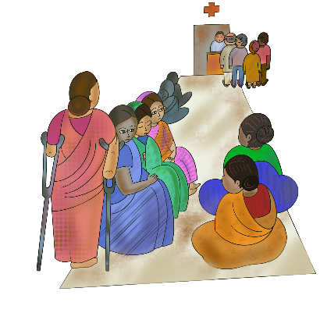

People with disabilities should not get worse care because of their disability or gender.

There should be rules for health services about this.

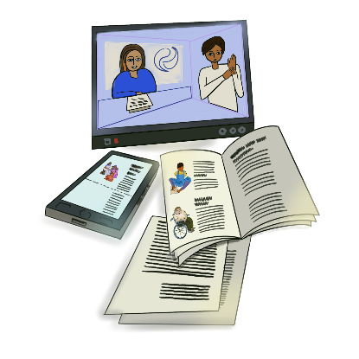
Get good information about:
- Health care and deaths to do with COVID-19
- Jobs and education during COVID-19.
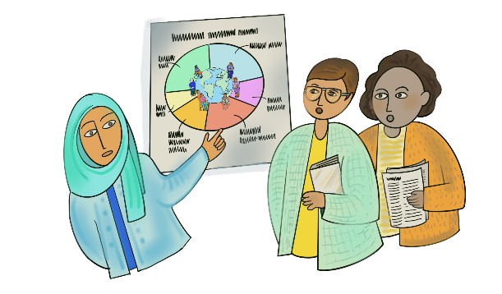
Make sure the information shows what is happening to people with disabilities.

Use the information to make the right plans for people with disabilities.

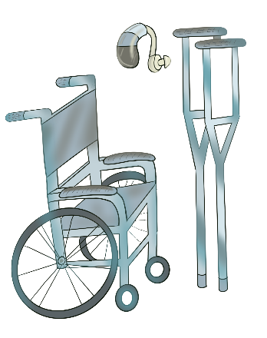
Make sure people with disabilities get the right support for their disability during COVID-19.

For example:

- Health care and mental health care

- Support to move around

- Equipment like wheelchairs and hearing aids

This support should be free or low cost.

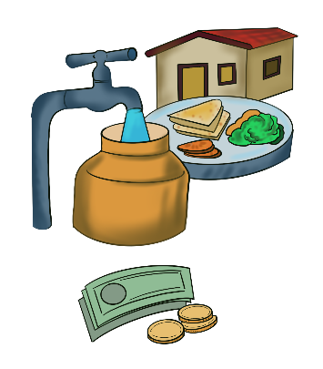
Make sure people with disabilities have enough money for the basic things they need.

For example:
- Clean water
- Food
- Housing
People with disabilities should also get money if they cannot work during COVID-19.

Work with people with disabilities to:

- Make plans about COVID-19.

For example, about money and support for people

- Check how the plans are working.

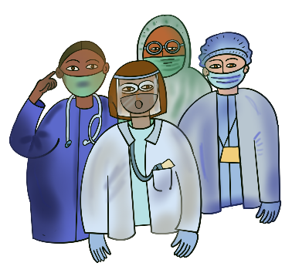
Make sure support workers can still support people with disabilities during COVID-19.

Make sure they get the right support to work.

Like face masks and tests for COVID-19.
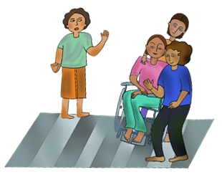

Talk to people in local communities.

Ask them to give support to people with disabilities and their families if they can.
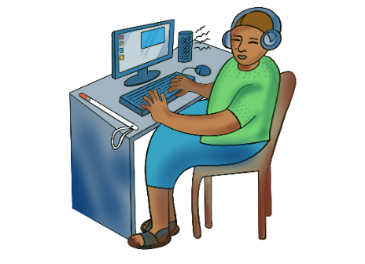
Give people with disabilities the support they need to learn at school or university.

People might have to learn on the internet during COVID-19.

Solve problems that were there before COVID-19
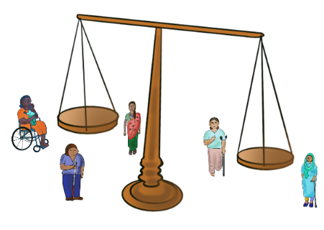

The main things to do

Make sure laws work well for people with disabilities and their rights.

For example, make sure countries follow laws in the world about the rights of people with disabilities and women and girls.

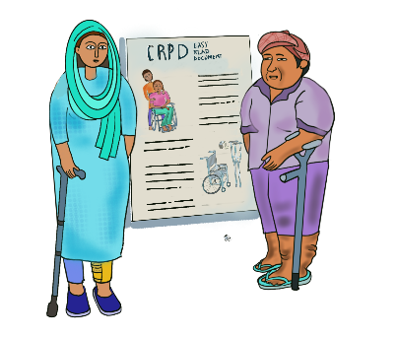
This includes a document about the rights of people with disabilities in the world.

It is called the Convention on the Rights of Persons with Disabilities.

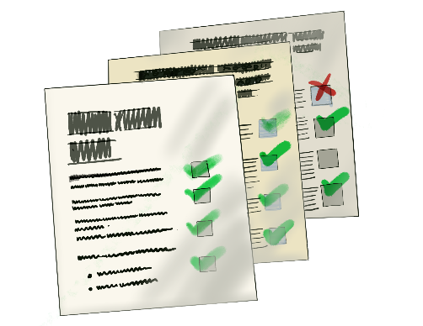
Make a plan about giving people with disabilities the right support to do with their bodies, sex, relationships and having children.

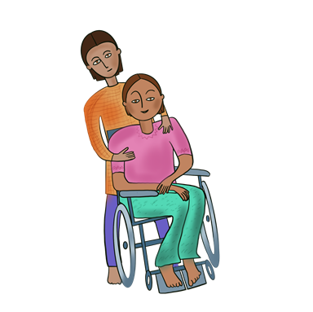
Make it easier for people with disabilities to get the right support to do with their bodies, sex, relationships and having children.

For example:

- Tell health workers how to make their services work well for people with disabilities
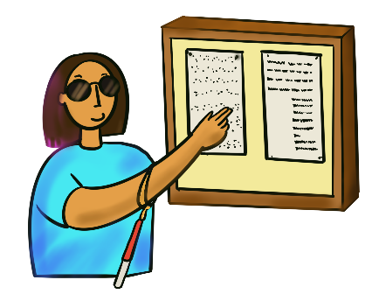
There should be rules about this

- Give people with disabilities information they can understand about health services.

And support to go to health appointments if they need it.

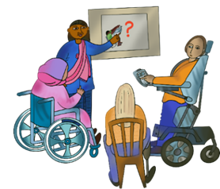
Check all health services to do with sex, relationships and having children.

Make plans about what needs to change for people with disabilities.

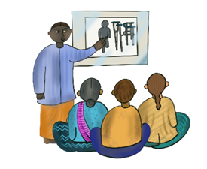

Make sure health workers get training about the rights of people with disabilities.

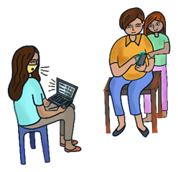
Work with people with disabilities to:

- Make plans about health care to do with relationships, sex and having children

- Check how the health care is working

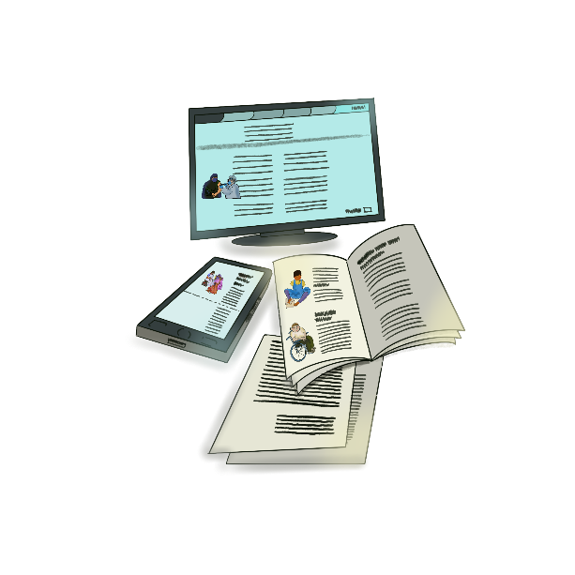

Get information about what is happening to people with disabilities to do with relationships, sex and having children.

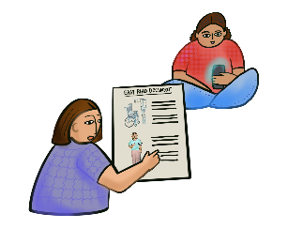

You can also read this report for more information.

It has easy words with pictures:

https://tinyurl.com/UNFPa-Guidelines

