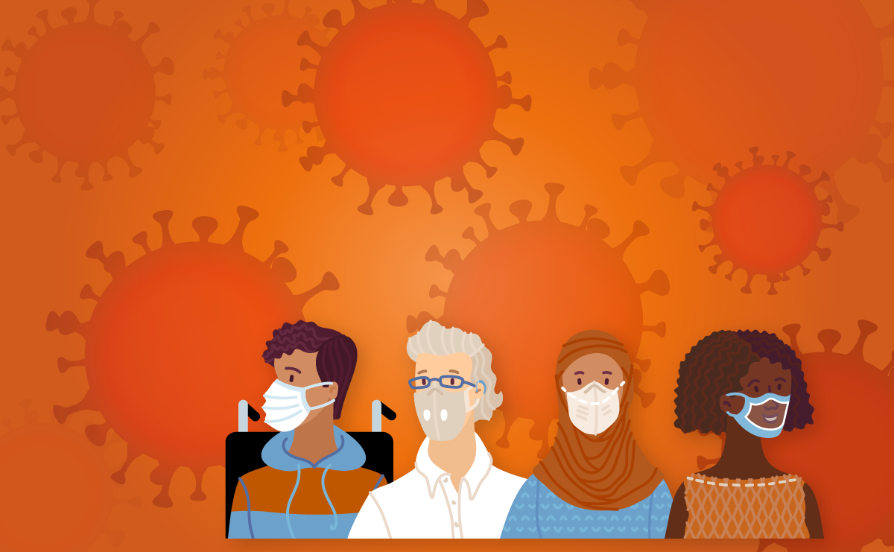
Women, Girls, and Gender Non-Conforming People
with Disabilities — Know Your Rights!
Gender-based Violence
during the Covid-19 Pandemic

What is Gender-Based Violence?
Gender-based violence is harm that happens to a person or a group of people because of their gender. Gender means whether someone acts and looks like what your community thinks a woman, a girl, a man, or a boy should act like or look like. Gender non-conforming people include people who do not act or look like what people would expect of women, girls, men, or boys in their communities.
Although gender-based violence can happen to anyone who is discriminated against because of their gender, it most often happens to women and girls. It also likely happens to gender non-conforming people with disabilities more often, but data about that is insufficient and more research is needed. It is important to report cases of gender-based violence to the police or other authorities that can help you, for example, health care professionals or teachers.
Gender-based violence can take many forms including physical, emotional, psychological, sexual, and financial violence and abuse. It can happen at home, on the street or elsewhere. Sexual harassment is also a form of gender-based violence. It happens when someone is trying to do sexual things with you when you do not want to. Gender-based violence is about gender inequality and discrimination, which means the way men and women are treated differently in a community, and is often impacted by other factors like race, disability, sexual orientation, and age.
The acronym “GBV” is often used as a way to refer to gender-based violence. If you experience GBV, it is never your fault. GBV is not normal, it is not ok for it to happen, and you have the right to seek help and for the violence and abuse to stop, as well as many other rights.
EXAMPLE: A man kicks his wife because he is unhappy that she did not prepare dinner for the family. In the man’s community, women are expected to prepare dinner each night for their families.
EXAMPLE: A female student who is romantically interested in women is raped by a male classmate who wants to force her to be attracted to men.
For people with disabilities, GBV can sometimes take unique forms like abuse by a support person; withholding of medication or an assistive device; or denial of necessities like food, money, and toileting support. GBV can happen once or many times. Perpetrators — the people who commit this violence — can include intimate partners (like a girlfriend or a husband), family members, caregivers, support staff, service providers, teachers, the police, or others. The perpetrator may be someone you know, but not always. The COVID-19 pandemic has increased the number of people experiencing or at risk of GBV, particularly people with disabilities.
EXAMPLE: A girl’s father takes away her wheelchair and locks her in her room because he is tired of providing her with support. During the pandemic, her professional support person could not help her anymore because of the fear of COVID infection.
EXAMPLE: A non-binary person who lives in an institution is screamed at and called bad names by one of the staff members. (A non-binary person is neither a man nor a woman. They are not the gender people said they were when they were born.)

What are my rights?
You have a right to be free from GBV. Your government must prevent, protect, investigate, punish, and support you if you experience GBV.
These rights are protected in many international documents called treaties, which your government may have ratified. If a government has ratified a treaty, that means your government has a duty to make sure the people in your country have those rights. Two important treaties for you to know about are the Convention on the Rights of Persons with Disabilities — also known as the CRPD — and the Convention on the Elimination of All Forms of Discrimination against Women — known as CEDAW.

You have the right under these and other treaties:
- To be treated equally and without discrimination based on your gender or your disability.
- To access the police and the court system to seek justice.
- To receive information about GBV and the COVID-19 pandemic in ways you can understand.
- To protection and safety during emergencies - such as a global pandemic, a natural disaster, or a war or conflict.
- To live independently and to be included in your community — including access to support services to help you live independently with the support you require.
- To health — including physical and psychological recovery from violence; sexual and reproductive health information, goods, and services; rehabilitation; public health information; vaccination programmes; and assistance reintegrating back into your community.
- To an adequate standard of living for yourself and your family and to social protection. The term ‘social protection’ means the government takes steps to make sure you and your family have access to the services you need — including being able to meet your basic needs such as having enough food, water, clothing, and fair housing.
- To be able to vote, express your opinion, and to be included in political processes.
- To accessible services such as shelters, GBV hotlines, emergency and support services, counselling services, and COVID-19 testing, treatment, and vaccination programmes.
- To reasonable accommodation, meaning that services, such as shelters, support services and COVID-19 programmes take steps to adapt to your needs when accessible services are not enough to provide the support you need.

What does it mean to be accessible?
Accessibility means that information, goods, and services can be used by people with disabilities on an equal basis with non-disabled people. This means that, among other actions, governments must make sure that different information and communication formats are available (such as digital, braille, sign language, plain language, and Easy-Read formats); that there are policy exceptions to allow service animals, interpreters, and support staff to accompany service recipients; that information, goods, and services are affordable, including with fee waivers; and that physical accessibility is provided, such as ramps, railings, and elevators. Physical services must also be easy and safe for people with disabilities to reach.
EXAMPLE: COVID-19 testing sites are located in a building that is wheelchair-accessible.
EXAMPLE: All public awareness campaigns on the TV about GBV include a sign-language interpreter.

What are my rights during the COVID-19 pandemic? What must my government do?
Your government must respect, protect, and fulfil your right to be free from GBV at all times. In fact, you have specific rights that must be guaranteed during and after an emergency such as this pandemic. At all times, and particularly during the COVID-19 pandemic:

Your government must respect your rights:
The government, and anyone who works for the government, are required to never commit GBV and to have laws in place making such violence illegal.
EXAMPLE: The Government passes a law that requires that doctors who work for public hospitals do not sterilize women with disabilities (stop them having children permanently) without their fully informed agreement to the procedure.

Your government must protect your rights:
The government must protect people with disabilities from GBV by acting to prevent and address GBV committed by people (like your family member, support person, or partner).
During the COVID-19 crisis, your government has a duty to be enacting laws, policies, and programmes that prevent and address GBV, including taking steps to address the stereotypes that contribute to violence against people with disabilities.
EXAMPLE: You have the right to the disability-related support services you require to be classified as essential services by law. This right is important to enable you to live independently and to not have to rely on your family or institutional settings for essential support services and basic needs like food, water and housing.
EXAMPLE: You have the right to be included in and to be able to understand the information featured in any GBV COVID-19 awareness-raising campaigns addressing the increased risk of violence during the COVID-19 pandemic and sharing information about available services.
During the COVID-19 crisis, your government has a duty to be providing adequate, timely, and accessible services to survivors of GBV to prevent further harm.
EXAMPLE: You have the right—even during COVID-19 lockdowns or stay-at-home orders—to leave your house to escape violence, seek help from the police, or access health and GBV services.
EXAMPLE: You have the right to use accessible public transportation to seek help after experiencing GBV even during COVID-19 lockdowns and restrictions.
EXAMPLE: You have the right to any disability-related accessibility supports you require when seeking healthcare, GBV services, or other forms of essential services, even where restrictions have been implemented during the COVID-19 pandemic.
EXAMPLE: You always have the right to have an interpreter or support person of your choice with you during a healthcare appointment. Your interpreter or support person must be considered an essential worker and provided with personal protective equipment.
EXAMPLE: You have the right to live in the community and not in an institution. If you live in an institution — like a nursing home, a group home, or a psychiatric facility — you have the right to have the government take additional steps to consider your needs and address the increased risk of violence you face because of gender and disability due to the COVID-19 pandemic.
EXAMPLE: If you live in an institution, someone who does not work for the government is required to regularly check if there are GBV cases in the institution. You have the right to talk to this person and report GBV.
EXAMPLE: You have the right to report GBV to the police or to others in a way that keeps your information private. If you want to, a person you trust can go with you to report the crime or support you to do it using a phone or the internet.

During the COVID-19 crisis, your government has a duty to be investigating, prosecuting, and punishing GBV by ordinary people.
EXAMPLE: You have the right to file a police report in an accessible way and to have the police take action to investigate allegations of GBV, even when they are busy enforcing COVID-19 restrictions.
EXAMPLE: You have the right to be able to seek an emergency protection order from the court system in an accessible way, even during lockdowns or court system shutdowns, and to have the police enforce that protection order.
EXAMPLE: The staff at hospitals, police stations, and shelters must be trained and know about your rights.
During the COVID-19 crisis, your government has a duty to be promoting the physical, mental, and psychological recovery, rehabilitation and social reintegration of survivors of GBV into their community.
EXAMPLE: You have the right to have psychosocial support services, like counselling or mental health hotlines, available in accessible formats such as digital and video formats, text messaging, and various languages, including local sign language.
EXAMPLE: You have the right to be able to visit service providers, including counsellors, trained on providing disability-inclusive services, and on how to provide strong referrals to other service providers for both GBV and disability-related needs if you experienced or are afraid of GBV.

Your government must fulfil your rights:
The government must make sure that people with disabilities can live a life free from GBV, including, for example, by ensuring that protection services are accessible and by training service providers on disability-inclusive services. The government must also ensure the participation of women, girls, and gender non-conforming people with disabilities in the COVID-19 preparation, response, and recovery process. The government must further provide funding to the court system where GBV is prosecuted to ensure that the victim support service’s office is fully accessible, has staff trained on disability-inclusion, and has a sign language interpreter on staff.
EXAMPLE: You have the right to be included in data collection and to access data disaggregated by both gender and disability on the impact of COVID-19 on GBV.
EXAMPLE: You have a right to be consulted in the government’s assessments of GBV during the COVID-19 pandemic, with funding and programming assigned accordingly.

If I experience GBV, what should I do?
- If you are experiencing an emergency, contact your local police or emergency provider. You should do this even if where you live is under a lockdown order or any other COVID-19 restrictions.
- Contact your local victim/survivor organisation or others providing GBV specialized services, such as hospitals or helplines for those who have experienced GBV. Use the internet (if you have a safe and confidential connection) or ask a trusted person to help you identify a safe and accessible way for you to contact them.
- Contact your local organisation of people with disabilities or disability support organisation to request a referral and/or assistance seeking accessible GBV services, or to join a support group for women, girls, and gender non-conforming people with disabilities.

Where can I learn more about GBV?
- UN Women, Ending Violence Against Women COVID-19 Briefs (2020-2021).
- UN Women and Women Enabled International (WEI), COVID-19, Gender, and Disability Checklist: Preventing and Addressing Gender-Based Violence against Women, Girls, and Gender Non-conforming Persons with Disabilities during the COVID-19 Pandemic (2021).
- UN Population Fund (UNFPA), UN Women, World Health Organization, U.N. Development Programme (UNDP), and U.N. Office on Drugs and Crime (UNODC), Essential Services for Women and Girls Subject to Violence (2015).
- UNFPA and WEI, Women and Young Persons with Disabilities: Guidelines for Providing Rights-Based and Gender-Responsive Services to Address Gender-Based Violence and Sexual and Reproductive Health and Rights (2018).

This publication was produced by UN Women and Women Enabled International in the context of the programme Building Back Better for All, supported by the United Nations Partnership on the Rights of Persons with Disabilities (UNPRPD) Multi Partner Trust Fund. This publication does not necessarily reflect the official position of the UNPRPD MPTF.

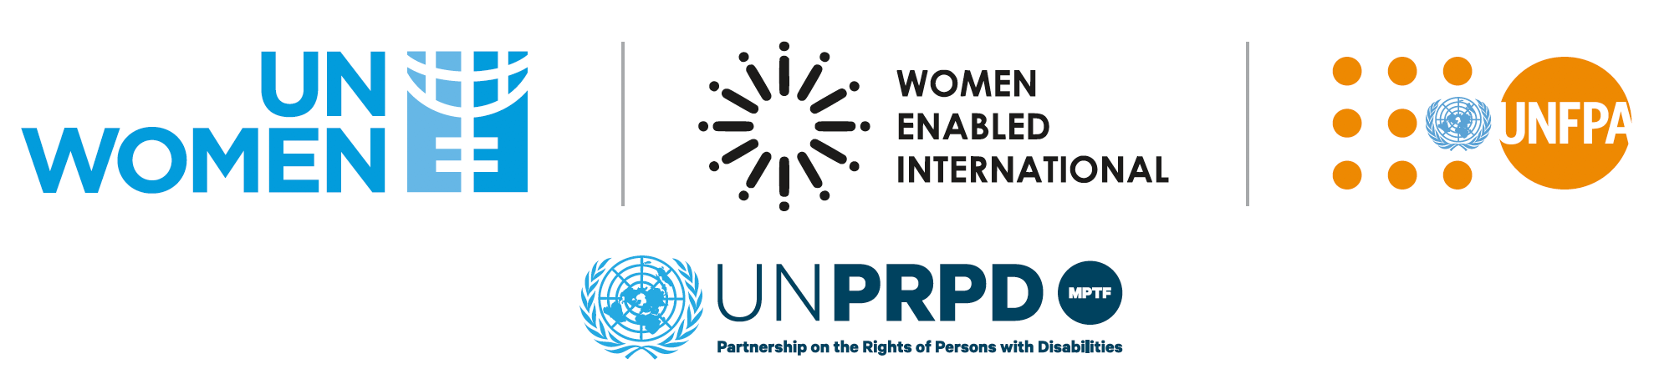

Endnotes

UN Women, Frequently Asked Questions: Types of Violence against Women and Girls (2021), https://www.unwomen.org/en/what-we-do/ending-violence-against-women/faqs/types-of-violence.
World Health Organization (WHO), Gender and Health (2021), https://www.who.int/health-topics/gender#tab=tab_1.
See, e.g., Human Rights Campaign, Glossary of Terms, https://www.hrc.org/resources/glossary-of-terms?utm_source=GS&utm_medium=AD&utm_campaign=BPI-HRC-Grant&utm_content=454853592927&utm_term=lgbt%20definition&gclid=Cj0KCQiAvvKBBhCXARIsACTePW-cHrQEQk0ockKXIUklmDzb__pARvs_nQeD-vN6vlFUjinbddeTHzgaAotsEALw_wcB.
See, e.g., Council of Europe, What is gender-based violence?, https://www.coe.int/en/web/gender-matters/what-is-gender-based-violence.
U.N. Human Rights Council, Report of the Independent Expert on protection against violence and discrimination based on sexual orientation and gender identity, para. 62 (2018), A/HRC/38/43.
UN Women, Frequently Asked Questions: Types of Violence against Women and Girls (2021), https://www.unwomen.org/en/what-we-do/ending-violence-against-women/faqs/types-of-violence.
See, e.g., Committee on the Rights of Persons with Disabilities (CRPD Committee), General Comment No. 3: Women and girls with disabilities, para. 31, U.N. Doc. CRPD/C/GC/3 (2016) [hereinafter CRPD Committee, Gen. Comment No. 3].
United Nations Population Fund (UNFPA) & Women Enabled International (WEI), Women and Young Persons with Disabilities: Guidelines for Providing Rights-Based and Gender-Responsive Services to Address Gender-Based Violence and Sexual and Reproductive Health and Rights 49-51 (2018), https://www.unfpa.org/featured-publication/women-and-young-persons-disabilities.
UN Women, COVID-19 and Ending Violence Against Women and Girls 1-2 (2020), https://www.unwomen.org/-/media/headquarters/attachments/sections/library/publications/2020/issue-brief-covid-19-and-ending-violence-against-women-and-girls-en.pdf?la=en&vs=5006.
Emma Pearce, Disability Considerations in GBV Programming during the COVID-19 Pandemic (Mar. 2020), http://www.sddirect.org.uk/media/1889/gbv-aor-research-query_covid-19-disability-gbv_final-version.pdf.
CEDAW Committee, General Recommendation No. 19: Violence against women, (11th Sess., 1992), in Compilation of General Comments and General Recommendations Adopted by Human Rights Treaty Bodies, U.N. Doc. HRI/GEN/1/Rev.9 (Vol. II) (2008).
Convention on the Rights of Persons with Disabilities, G.A. Res. 61/106, U.N. Doc. A/RES/61/106 (Dec. 13, 2006) [hereinafter CRPD].
Convention on the Elimination of All Forms of Discrimination against Women, adopted Dec. 18, 1979, G.A. Res. 34/180, U.N. GAOR, 34th Sess., Supp. No. 46, at 193, U.N. Doc. A/34/46, U.N.T.S. 13 (entered into force Sept. 3, 1981) [hereinafter CEDAW].
International Covenant on Civil and Political Rights, adopted Dec. 16, 1966, art. 2, G.A. Res. 2200A (XXI), U.N. GAOR, 21st Sess., Supp. No. 16, U.N. Doc. A/6316 (1966), 999 U.N.T.S. 171 (entered into force Mar. 23, 1976) [hereinafter ICCPR]; International Covenant on Economic, Social and Cultural Rights, art. 2, G.A. Res. 2200A (XXI), U.N. GAOR, Supp. No. 16, U.N. Doc. A/6316 (1966) [hereinafter IESCR]; CRPD, supra note 12, arts. 5-7; CEDAW, supra note 13, arts. 1 & 3; Convention on the Rights of the Child, adopted Nov. 20, 1989, arts. 2,5, G.A. Res. 44/25, annex, U.N. GAOR, 44th Sess., Supp. No. 49, U.N. Doc. A/44/49 (1989) (entered into force Sept. 2, 1990) [hereinafter CRC]; Protocol to the African Charter on Human and Peoples’ Rights on the Rights of Women in Africa, 2nd Ordinary Sess., Assembly of the Union, adopted July 11, 2003, arts. Arts. 2-3 [hereinafter African Charter]; Inter-American Convention on the Prevention, Punishment, and Eradication of Violence against Women, art. 4, 33 I.L.M. 1534 [hereinafter American Convention]; Council of Europe, Convention on Preventing and Combating Violence against Women and Domestic Violence, art. 5 (entry into force Aug. 1, 2014) [hereinafter Istanbul Convention].
ICCPR, supra note 14, art. 26; CRPD, supra note 12, arts. 12 & 13; African Charter, supra note 14, art. 3; American Convention, supra note 14, art. 3.
CRPD, supra note 12, art. 8.
Id., art. 11; African Charter, supra note 14, art. 18.
CRPD, supra note 12, art. 19.
Id., arts. 16(4) & 25; CRC, supra note 14, art. 39; Istanbul Convention, supra note 14, art. 20.
ICESCR, supra note 14, art. 11; CRPD, supra note 12, art. 28.
ICESCR, supra note 14, art. 11; CRPD, supra note 12, art. 28.
ICESCR, supra note 14, art. 11; CRPD, supra note 12, art. 28.
CRPD, supra note 12, art. 29.
Id., art. 9; Istanbul Convention, supra note 14, art. 20.
CRPD Committee, General Comment No. 2: Article 9: Accessibility, para. 13, U.N. Doc. CRPD/C/GC/2 (2016).
Id., paras. 20, 27-33.
UN Women, UNFPA, WHO et al, Essential Services Package for Women and Girls Subject to Violence 14 (2015), https://www.unfpa.org/essential-services-package-women-and-girls-subject-violence.
WEI, The Right to Women and Girls with Disabilities to be free from Gender-Based Violence, https://womenenabled.org/fact-sheets.html.
See Vienna Convention on the Law of Treaties, art. 26, 1155 U.N.T.S. 331 (1980); Human Rights Committee, General Comment No. 35: Article 9 (Liberty and security of person), para. 9, U.N. Doc. CCPR/C/GC/35 (2014) [hereinafter HRC, Gen. Comment No. 35]; CRPD Committee, Gen. Comment No. 3, supra note 7, para. 25.
CRPD Committee, Gen. Comment No. 3, supra note 7, para. 25.
See Vienna Convention on the Law of Treaties, art. 26, 1155 U.N.T.S. 331 (1980); Human Rights Committee, General Comment No. 31: Nature of the General Legal Obligations Imposed on States Parties to the Covenant, para. 8, U.N. Doc. CCPR/C/21/Rev.1/Add.13 (2004); HRC, Gen. Comment No. 35, supra note 29, para 9; CRPD Committee, Gen. Comment No. 3, supra note 7, para. 26; ESCR Committee, General Comment No. 22 (2016) on the Right to Sexual and Reproductive Health (Article 12 of the International Covenant on the Economic, Social and Cultural Rights, para. 41, U.N. Doc. E/C.12/GC/22 (2016) [hereinafter ESCR Committee, Gen. Comment No. 22].
UN Women, Policy Brief No. 17: COVID-19 and Violence Against Women and Girls: Addressing the Shadow Pandemic 6-7 (2021), https://www.unwomen.org/en/digital-library/publications/2020/06/policy-brief-covid-19-and-violence-against-women-and-girls-addressing-the-shadow-pandemic.
Id.
CRPD Committee, Gen. Comment No. 3, supra note 7.
UN Women, Policy Brief No. 17: COVID-19 and Violence Against Women and Girls: Addressing the Shadow Pandemic 6-7 (2021), https://www.unwomen.org/en/digital-library/publications/2020/06/policy-brief-covid-19-and-violence-against-women-and-girls-addressing-the-shadow-pandemic.
See Vienna Convention on the Law of Treaties, art. 26, 1155 U.N.T.S. 331 (1980); ESCR Committee, Gen. Comment No. 22, supra note 31, para. 42; CRPD Committee, Gen. Comment No. 3, supra note 7, para. 27.
CRPD, supra note 12, art. 11; African Charter, supra note 14, art. 18.
ESCR Committee, Gen. Comment No. 22, supra note 31, para. 45.

